**INCOME TAX FRAUD DETECTION IDEA USING AI AND ML**

## A PROJECT REPORT

***Submitted by,***

**Mr. Ranganath R - 20211CST0035**

**Mr. Uday G - 20211CST0063**

**Mr. Rohith M - 20211CST0107**

**Mr. Abhishek V - 20211CST0099**

**Mr. Karthik Kumar SM - 20211CST0048**

***Under the guidance of,***

**Dr. Saira Banu Atham**

Professor & HOD, School of Computer Science and Engineering

***in partial fulfillment for the award of the degree of***

**BACHELOR OF TECHNOLOGY**

**IN**

**COMPUTER SCIENCE AND ENGINEERING**

**At**



**PRESIDENCY UNIVERSITY**

**BENGALURU DECEMBER 2024**

**PRESIDENCY UNIVERSITY**

**SCHOOL OF COMPUTER SCIENCE ENGINEERING**

**CERTIFICATE**

This is to certify that the Project report **“Income Tax Fraud Detection Idea Using AI and ML”** being submitted by Uday G, bearing roll number 20211CST0063 in partial fulfillment of the requirement for the award of the degree of Bachelor of Technology in Computer Science and Engineering is a bonafide work carried out under my supervision.

|  |
| --- |
| **Dr. Saira Banu Atham**  Professor & HoD  School of CSE  Presidency University |

|  |  |  |
| --- | --- | --- |
| **Dr. L. SHAKKEERA**  Associate Dean  School of CSE  Presidency University | **Dr. MYDHILI NAIR**  Associate Dean  School of CSE  Presidency University | **Dr. SAMEERUDDIN KHAN**  Pro-Vc School of Engineering  Dean -School of CSE&IS  Presidency University |

**PRESIDENCY UNIVERSITY**

**PRESIDENCY SCHOOL OF COMPUTER SCIENCE ENGINEERING**

**CERTIFICATE**

This is to certify that the Project report **“Income Tax Fraud Detection Idea Using AI and ML”** being submitted by Ranganath R, bearing roll number 20211CST0035 in partial fulfillment of the requirement for the award of the degree of Bachelor of Technology in Computer Science and Engineering is a bonafide work carried out under my supervision.

|  |
| --- |
| **Dr. Saira Banu Atham**  Professor & HoD  School of CSE  Presidency University |

|  |  |  |
| --- | --- | --- |
| **Dr. L. SHAKKEERA**  Associate Dean  School of CSE  Presidency University | **Dr. MYDHILI NAIR**  Associate Dean  School of CSE  Presidency University | **Dr. SAMEERUDDIN KHAN**  Pro-Vc School of Engineering  Dean -School of CSE&IS  Presidency University |

**PRESIDENCY UNIVERSITY**

**PRESIDENCY SCHOOL OF COMPUTER SCIENCE**

**CERTIFICATE**

This is to certify that the Project report **“Income Tax Fraud Detection Idea Using AI and ML”** being submitted by Rohith M, bearing roll number 20211CST0107 in partial fulfillment of the requirement for the award of the degree of Bachelor of Technology in Computer Science and Engineering is a bonafide work carried out under my supervision.

|  |
| --- |
| **Dr. Saira Banu Atham**  Professor & HoD  School of CSE  Presidency University |

|  |  |  |
| --- | --- | --- |
| **Dr. L. SHAKKEERA**  Associate Dean  School of CSE  Presidency University | **Dr. MYDHILI NAIR**  Associate Dean  School of CSE  Presidency University | **Dr. SAMEERUDDIN KHAN**  Pro-Vc School of Engineering  Dean -School of CSE&IS  Presidency University |

**PRESIDENCY UNIVERSITY**

**PRESIDENCY SCHOOL OF COMPUTER SCIENCE**

**CERTIFICATE**

This is to certify that the Project report **“Income Tax Fraud Detection Idea Using AI and ML”** being submitted by Abhishek V, bearing roll number 20211CST0099 in partial fulfillment of the requirement for the award of the degree of Bachelor of Technology in Computer Science and Engineering is a bonafide work carried out under my supervision.

|  |
| --- |
| **Dr. Saira Banu Atham**  Professor & HoD  School of CSE  Presidency University |

|  |  |  |
| --- | --- | --- |
| **Dr. L. SHAKKEERA**  Associate Dean  School of CSE  Presidency University | **Dr. MYDHILI NAIR**  Associate Dean  School of CSE  Presidency University | **Dr. SAMEERUDDIN KHAN**  Pro-Vc School of Engineering  Dean -School of CSE&IS  Presidency University |

**PRESIDENCY UNIVERSITY**

**PRESIDENCY SCHOOL OF COMPUTER SCIENCE**

**CERTIFICATE**

This is to certify that the Project report **“Income Tax Fraud Detection Idea Using AI and ML”** being submitted by Karthik Kumar S M, bearing roll number 20211CST0048 in partial fulfillment of the requirement for the award of the degree of Bachelor of Technology in Computer Science and Engineering is a bonafide work carried out under my supervision.

|  |
| --- |
| **Dr. Saira Banu Atham**  Professor & HoD  School of CSE  Presidency University |

|  |  |  |
| --- | --- | --- |
| **Dr. L. SHAKKEERA**  Associate Dean  School of CSE  Presidency University | **Dr. MYDHILI NAIR**  Associate Dean  School of CSE  Presidency University | **Dr. SAMEERUDDIN KHAN**  Pro-Vc School of Engineering  Dean -School of CSE&IS  Presidency University |

**PRESIDENCY UNIVERSITY**

**PRESIDENCY SCHOOL OF COMPUTER SCIENCE**

**DECLARATION**

We hereby declare that the work, which is being presented in the project report entitled **Income Tax Fraud Detection Idea Using AI and ML** in partial fulfillment for the award of Degree of **Bachelor of Technology** in **Computer Science and Engineering**, is a record of our own investigations carried under the guidance of **Dr. Saira Banu Atham, Professor & HOD,** **School of Computer Science and Engineering, Presidency University, Bengaluru.**

We have not submitted the matter presented in this report anywhere for the award of any other Degree.

|  |  |  |
| --- | --- | --- |
| **Student Name** | **Roll Number** | **Signature** |
| Uday G | 20211CST0063 |  |

**PRESIDENCY UNIVERSITY**

**PRESIDENCY SCHOOL OF COMPUTER SCIENCE**

**DECLARATION**

We hereby declare that the work, which is being presented in the project report entitled **Income Tax Fraud Detection Idea Using AI and ML** in partial fulfillment for the award of Degree of **Bachelor of Technology** in **Computer Science and Engineering**, is a record of our own investigations carried under the guidance of **Dr. Saira Banu Atham, Professor & HOD,** **School of Computer Science and Engineering, Presidency University, Bengaluru.**

We have not submitted the matter presented in this report anywhere for the award of any other Degree.

|  |  |  |
| --- | --- | --- |
| **Student Name** | **Roll Number** | **Signature** |
| Ranganath R | 20211CST0035 |  |

**PRESIDENCY UNIVERSITY**

**PRESIDENCY SCHOOL OF COMPUTER SCIENCE**

**DECLARATION**

We hereby declare that the work, which is being presented in the project report entitled **Income Tax Fraud Detection Idea Using AI and ML** in partial fulfillment for the award of Degree of **Bachelor of Technology** in **Computer Science and Engineering**, is a record of our own investigations carried under the guidance of **Dr. Saira Banu Atham, Professor & HOD,** **School of Computer Science and Engineering, Presidency University, Bengaluru.**

We have not submitted the matter presented in this report anywhere for the award of any other Degree.

|  |  |  |
| --- | --- | --- |
| **Student Name** | **Roll Number** | **Signature** |
| Rohith M | 20211CST0107 |  |

**PRESIDENCY UNIVERSITY**

**PRESIDENCY SCHOOL OF COMPUTER SCIENCE**

**DECLARATION**

We hereby declare that the work, which is being presented in the project report entitled **Income Tax Fraud Detection Idea Using AI and ML** in partial fulfillment for the award of Degree of **Bachelor of Technology** in **Computer Science and Engineering**, is a record of our own investigations carried under the guidance of **Dr. Saira Banu Atham, Professor & HOD,** **School of Computer Science and Engineering, Presidency University, Bengaluru.**

We have not submitted the matter presented in this report anywhere for the award of any other Degree.

|  |  |  |
| --- | --- | --- |
| **Student Name** | **Roll Number** | **Signature** |
| Abhishek V | 20211CST0099 |  |

**PRESIDENCY UNIVERSITY**

**PRESIDENCY SCHOOL OF COMPUTER SCIENCE**

**DECLARATION**

We hereby declare that the work, which is being presented in the project report entitled **Income Tax Fraud Detection Idea Using AI and ML** in partial fulfillment for the award of Degree of **Bachelor of Technology** in **Computer Science and Engineering**, is a record of our own investigations carried under the guidance of **Dr. Saira Banu Atham, Professor & HOD,** **School of Computer Science and Engineering, Presidency University, Bengaluru.**

We have not submitted the matter presented in this report anywhere for the award of any other Degree.

|  |  |  |
| --- | --- | --- |
| **Student Name** | **Roll Number** | **Signature** |
| Karthik Kumar S M | 20211CST0048 |  |

**ABSTRACT**

Income tax fraud is a significant challenge faced by governments worldwide, leading to substantial revenue losses and undermining the fairness of taxation systems. Traditional methods of detecting fraudulent transactions are often manual, time-consuming, and prone to errors. To address these issues, this project leverages the power of Artificial Intelligence (AI) and Machine Learning (ML) to develop an automated system for income tax fraud detection.

The proposed system is designed to analyse financial transactions and identify anomalies indicative of fraudulent behaviour. A synthetic dataset was generated, simulating real-world transactions with features such as transaction type, amount, account balances, time, and location. Fraudulent transactions were embedded based on predefined probabilities to enable controlled experimentation. The data was then pre-processed to ensure compatibility with advanced predictive models, involving steps like feature encoding, normalization, and train-test splitting.

The system employs both machine learning models, such as Random Forest and Decision Trees, and deep learning architectures, including Fully Connected Neural Networks (FCNN) and Long Short-Term Memory (LSTM) networks. These models were trained and evaluated using metrics like accuracy, precision, recall, and F1 score to ensure robust performance. The best-performing models demonstrated a high level of accuracy (88%) and strong recall (83%), effectively detecting a significant number of fraudulent transactions while minimizing false positives.

This project demonstrates the potential of AI/ML in automating fraud detection, ensuring accuracy, and enhancing the integrity of taxation systems. Future work will focus on real-time fraud detection, integration with government databases, and the inclusion of additional features to improve system reliability and scalability.

**ACKNOWLEDGEMENT**

First of all, we indebted to the **GOD ALMIGHTY** for giving me an opportunity to excel in our efforts to complete this project on time.

We express our sincere thanks to our respected dean **Dr. Md. Sameeruddin Khan**, Pro-VC, School of Engineering and Dean, School of Computer Science Engineering & Information Science, Presidency University for getting us permission to undergo the project.

We express our heartfelt gratitude to our beloved Associate Deans **Dr. Shakkeera L and Dr. Mydhili Nair,** School of Computer Science Engineering & Information Science, Presidency University, and Dr. Asif Mohammed, Head of the Department, School of Computer Science Engineering & Information Science, Presidency University, for rendering timely help in completing this project successfully.

We are greatly indebted to our guide **Dr. Saira Banu Atham, Professor** and Reviewer **Dr. Saravana Kumar S, Associate professor**, School of Computer Science Engineering & Information Science, Presidency University for her inspirational guidance, and valuable suggestions and for providing us a chance to express our technical capabilities in every respect for the completion of the project work.

We would like to convey our gratitude and heartfelt thanks to the PIP2001 Capstone Project Coordinators **Dr. Sampath A K, Dr. Abdul Khadar A and Mr. Md Zia Ur Rahman,** department Project Coordinators “Dr. Manjula HM” and Git hub coordinator **Mr. Muthuraj.**

We thank our family and friends for the strong support and inspiration they have provided us in bringing out this project.

**Ranganath R**

**Uday G**

**Rohith M**

**Abhishek V**

**Kathik Kumar S M**

**LIST OF TABLES**

|  |  |  |  |
| --- | --- | --- | --- |
| **Sl. No.** | **Table Name** | **Table Caption** | **Page No.** |
| 1  2  3  4  5 | Table 6.1  Table 6.2  Table 8.1  Table 8.2  Table 9.1 | Preprocessing Techniques  Challenges in Fraud Detection  Models used and their characteristics  Comparison of Fraud detection Techniques  Performance Matrices comparison | 46  49  53  54  59 |

**LIST OF FIGURES**

|  |  |  |  |
| --- | --- | --- | --- |
| **Sl. No.** | **Figure Name** | **Caption** | **Page No.** |
| 1  2  3  4  5  6  7  8  9  10 | Fig 3.1  Fig 3.2  Fig 4.1  Fig 4.2  Fig 4.3  Fig 5.1  Fig 6.1  Fig 6.2  Fig 8.1  Fig 9.1 | Dynamic fraud detection challenges  Flowchart representation of research gaps  Fraud detection workflow  Simplified diagram illustrating the chunk-based processing techniques  Flowchart illustrating the end-to-end process followed in the research  Real time fraud detection system objectives  Modular architecture for fraud detection  Dataflow diagram  Visualization of results and future directions  Comparative performance of models | 14  16  21  22  24  31  37  44  56  59 |

**TABLE OF CONTENTS**

**CERTIFICATE** .................................................................................................................... ii  
**DECLARATION** ................................................................................................................. vi  
**ABSTRACT** ....................................................................................................................... x  
**ACKNOWLEDGEMENT** ........................................................................................................ xi

1. **INTRODUCTION** ................................................................................................................. 1  
   1.1 Background ........................................................................................................... 1  
   1.2 Objectives of the Study ....................................................................................... 2  
   1.3 Significance of the Study ..................................................................................... 3  
   1.4 Overview of Methodologies ................................................................................. 3  
   1.5 Challenges in Fraud Detection ............................................................................ 4  
   1.6 Contribution of the Study .................................................................................... 5  
   1.7 Expanding the Applications and Future Considerations ................................................. 5
2. **LITERATURE SURVEY** ...................................................................................................... 7
3. **RESEARCH GAPS OF EXISTING METHODS** ............................................................ 13  
   3.1 Data Imbalance and Representation .................................................................... 13  
   3.2 Dynamic and Evolving Fraud Patterns ............................................................... 13  
   3.3 Real-Time Detection Inability ............................................................................. 14  
   3.4 Interpretability and Transparency ....................................................................... 14  
   3.5 Ethical and Privacy Concerns .............................................................................. 15  
   3.6 Integration with Emerging Technologies ........................................................... 15  
   3.7 Future Directions .......................................................................................................... 16
4. **PROPOSED METHODOLOGY** ....................................................................................... 17  
   4.1 Dataset Description ............................................................................................. 18  
   4.2 Model Selection .................................................................................................. 18  
   4.3 Pre-processing Techniques ................................................................................. 19  
   4.4 Implementation Workflow ................................................................................. 21  
   4.5 Evaluation Metrics ............................................................................................... 23  
   4.6 Integration Techniques of AI .............................................................................. 25  
   4.7 Proposed Innovations .......................................................................................... 26  
   4.8 Potential Challenges ...................................................................................................... 27
5. **OBJECTIVES** ................................................................................................................. 29  
   5.1 Specific Objectives .............................................................................................. 29  
   5.2 Broader Implications .......................................................................................... 32  
   5.3 Key Challenges Addressed ................................................................................. 33  
   5.4 Proposed Innovations ......................................................................................... 34  
   5.5 Summary ........................................................................................................................ 35
6. **SYSTEM DESIGN AND IMPLEMENTATION** .............................................................. 36  
   6.1 System Architecture ............................................................................................ 37  
   6.1.1 Data Ingestion Layer ................................................................................... 38  
   6.1.2 Feature Engineering Module ...................................................................... 38  
   6.1.3 Machine Learning and Deep Learning Models ......................................... 40  
   6.1.4 Evaluation and Feedback Loop .................................................................. 41  
   6.2 Data Flow Diagram ............................................................................................ 42  
   6.3 Implementation Steps ......................................................................................... 45  
   6.3.1 Data Pre-processing .................................................................................. 45  
   6.3.2 Training and Testing ................................................................................. 47  
   6.4 Challenges Encountered ..................................................................................... 48  
   6.5 Summary ....................................................................................................................... 49
7. **TIMELINE FOR EXECUTION OF PROJECT(GANTT CHART)** ........................... 50
8. OUTCOMES ................................................................................................................. 51  
   8.1 Overview of Results ............................................................................................ 51  
   8.2 Detailed Model Analysis .................................................................................... 51  
   8.2.1 Random Forest Classifier ......................................................................... 51  
   8.2.2 Decision Tree Classifier ............................................................................ 51  
   8.2.3 Support Vector Machine (SVM) ………………………………………..... 52  
   8.2.4 Autoencoders ……………………………………………………………………….52  
   8.2.5 Long Short-Term Memory Network ......................................................... 52  
   8.3 Comparative Analysis ........................................................................................ 53  
   8.4 Key Findings ....................................................................................................... 54  
   8.5 Visualization of Results ................................................................................................ 55
9. RESULTS AND DISCUSSIONS .................................................................................... 57  
   9.1 Model Performance Results ................................................................................ 57  
   9.2 In-depth Results Analysis ................................................................................... 57  
   9.2.1 Random Forest Classifier ......................................................................... 57  
   9.2.2 Decision Tree Classifier ............................................................................ 58  
   9.2.3 Support Vector Machine (SVM) ............................................................................................ 58  
   9.2.4 Autoencoder (Autoencoders) ..................................................... 58  
   9.2.5 Long Short-Term Memory (LSTM) ......................................................... 58  
   9.3 Comparative Discussion ..................................................................................... 59  
   9.3.1 Accuracy and Efficiency ........................................................................... 60  
   9.3.2 Interpretability ........................................................................................................... 60
10. **CONCLUSION** ............................................................................................................. 61  
    10.1 Summary of Objectives and Methodology ....................................................... 61  
    10.1.1 Research Objectives ................................................................................ 61  
    10.1.2 Methodology ........................................................................................... 62  
    10.2 Key Findings ..................................................................................................... 63  
    10.2.1 Model Performance ................................................................................ 63  
    10.2.2 Insights ................................................................................................... 64  
    10.3 Challenges Faced .............................................................................................. 65  
    10.4 Contributions of the Study ............................................................................... 66  
    10.5 Recommendations for Future Research ........................................................................ 67

**REFERENCES** ................................................................................................................................. 69

**APPENDICES** .............................................................................................................................. 71  
A. Pseudocode .......................................................................................................................... 71  
B. Screenshots .............................................................................................................................. 75  
C. Enclosures ..................................................................................................................................... 76

**CHAPTER-1**

**INTRODUCTION**

#### 1.1 Background

The rapid advance of the digital financial system and exponential transactional volumes have led to never-before-seen complexities in fraud-detection landscapes. Complexifying the inter-connected, sophistication of financial transactions beyond an ordinary level, these now-advanced fraud-detection means are often insufficient to combat modern schemes and ideas of fraud effectively. Tax income fraud represents the one of the significant forms of financial malpractice that undermines the credibility and trust of the tax systems towards the public; affects and reduces government revenues that play a crucial role for any economy; and distorts it. The need for efficient, scalable and robust systems within the ambit of fraud detection has grown to become more urgent than ever in the past.

Machine learning (ML) and Deep learning (DL) indeed are very revolutionary and groundbreaking technologies under this particular research field and domain of application. The technology's ability to go through significant chunks of data, identify and interpret even the most obscure and complicated patterns, and be responsive to the methods by fraudulent actions which continue to evolve ensures their necessity for the critical business of detecting fraud. One after the other, most popular models of ML with examples like Random Forest, Support Vector Machine (SVM), and Decision Trees consistently have shown superb results in recognizing and pinpointing the fraudulent patterns that were embedded within structured datasets while establishing efficiency and reliability towards combating fraud. In a similar way, deep learning models, which include Autoencoders and LSTM, offer powerful capabilities that allow for the discovery of complex relationships and the identification of anomalies in large, dynamic datasets. The use of these new approaches has the incredible potential to revolutionize the field by fully automating the detection process and improving accuracy in ways that were impossible to achieve before.

The increasing complexity of financial systems in our modern world does call for high advancements in fraud detection mechanisms. As fraudsters grow sophisticated and cunning about their schemes, it then becomes evident that traditional rule-based systems are just not cut out for dealing with the subtle nuances and intricacies of modern fraudulent behavior. Although rule-based systems may work well in predetermined scenarios that have been foreseen, these systems are inherently lacking in necessary adaptability and flexibility needed to identify and respond properly to new and evolving fraudulent schemes that are constantly being produced. This gap reflects the need to utilize emerging technologies like ML and DL, which allow for adaptation based on data and changing fraudulent patterns. In addition, the ability of these models to handle large, diverse datasets makes them the best fit for dealing with the challenges that complex financial transactions pose.

Income tax fraud detection is a complex and critical process that identifies several kinds of fraudulent activities occurring around tax-related data. This type of detection involves a significant number of fraudulent behaviors, which notably include reporting less income than one possesses, over-claiming various deductions, and preparing false important documents. What complicates it further is the detection process with vast amounts of data as well as class imbalance; this might cause results not to be so fair, especially when dealing with fraud whose nature keeps on changing continuously with new regulations and methods invented. As a result, researchers and practitioners alike tend to pay attention and offer their efforts to using solutions driven by AI in efforts to improve detection capabilities while enhancing outcomes in general. These innovative solutions have the effect of not only improving the general efficiency of fraud detection but also raising the accuracy level in the overall processes of detecting fraud; they also powerfully build scalability and robustness in the diverse detection systems that are at hand.

#### 1.2 Objectives of the Study

The primary objective of this research work is to review the ability of ML and DL models to be applied in detecting income tax fraud. The aim of this research is to comparatively evaluate different models such as Random Forest, Decision Trees, Support Vector Machine (SVM), Autoencoders, and LSTM for their capability to serve as effective detection models in fraud detection. Their performance metrics include accuracy, precision, recall, F1-score, and computational efficiency. Furthermore, it studies the pattern transactions and anomalies linked with fraudulent activity. In its study, it is observed that it identifies pros and cons of ML and DL techniques used in detecting fraud related to income tax return and comes up with scopes of improvement to achieve precise accuracy and efficiency of its detection systems at scale. Apart from these, it tends to furnish a profound acquaintance with factors that might effect the model's performance as well.

It looks into the effect of preprocessing techniques, feature engineering, and hyperparameter tuning on the effectiveness of ML and DL models. This research systematically analyzes the various aspects to provide actionable insights that improve the design and implementation of fraud detection systems. Furthermore, the study brings to the fore the balance needed between detection accuracy and computational efficiency to ensure the practicality of proposed solutions in real-world applications.

#### 1.3 Significance of the Study

This will not only be a threat to governmental financial stability but also a ripple effect on public welfare programs and infrastructure development. The detection of such frauds in a timely and accurate manner is essential to ensure transparency and foster public trust in tax systems. Through the application of ML and DL, this study contributes to the development of advanced, data-driven fraud detection systems. In view of the findings of the above study, policymakers, financial houses, and technology developers should adopt more effective strategies toward curbing income tax fraud. The relevance of the study is not limited by the immediate context of its application in income tax fraud detection.

The methodologies and the findings can be generalized across other domains where fraud detection is critical, such as banking, insurance, or e-commerce. Such studies demonstrate the applicability of the two models, ML and DL, in diverse settings; hence, it underscores versatility and potential in these technologies. The research also stresses the ethical implications of fraud detection, where fairness, transparency, and accountability will play a crucial role in design and deployment.

#### 1.4 Overview of Methodologies

In the end, supervised, unsupervised, and hybrid methodologies will be used for detecting income tax fraud. Here, models of ML employed are the Random Forest model, the Decision Trees model, and the Support Vector Machine (SVM) model. The models of DL used are the Autoencoders and the LSTM model. Such models are applied to an extremely imbalanced synthetic dataset with a 0.9% fraud rate and comprise 1 million entries. Preprocessing techniques, including feature engineering, one-hot encoding of categorical features, and normalization, are applied to enhance model performance. The research uses a chunk-based processing approach to manage large datasets efficiently, thus making the approach scalable and reducing the computational costs. The selection of models for this research is guided by their proven effectiveness in handling structured datasets and detecting anomalies.

Random Forest is an ensemble learning method, known to be robust and able to capture complex patterns. Decision Trees are interpretive and straightforward; they are ideal when there is a need for fast decision-making. Support Vector Machine (SVM) is a gradient boosting algorithm that excels both in terms of accuracy and computational efficiency, which has become popular in fraud detection. Autoencoders and LSTM, although they have classic applications in image and sequential data, are used to retrieve meaningful features from structured financial data.

#### 1.5 Challenges in Fraud Detection

One of the most significant challenges facing fraud detection systems in modern financial transactions is complexity. Some of the main challenges include data imbalance where fraudulent transactions often constitute a very small proportion of the entire dataset. This, in turn, creates skewed class distributions that can easily impact model performance. Dynamic fraud patterns present another challenge where fraudsters are constantly changing their techniques and this makes static models become ineffective. Scalability is a significant issue because of the enormous scale of financial datasets, and models that can handle large volumes of data without sacrificing accuracy or efficiency are required. Interpretability is also a major challenge, as deep learning models, often considered "black boxes," are not transparent, and it is difficult to interpret their predictions and gain stakeholders' trust. Finally, computational costs associated with training complex models on large datasets demand significant resources that may limit their practical deployment. The problem of data imbalance is particularly critical in the context of fraud detection.

Fraudulent transactions are rare compared to legitimate ones, and this results in imbalanced datasets that bias models towards the majority class. This bias can lead to high accuracy rates masking poor detection of fraudulent cases. To overcome this, techniques such as oversampling, under sampling, and synthetic data generation are used to balance the dataset. Cost-sensitive learning approaches are also explored to penalize the misclassification of the minority class for better model performance. Dynamic fraud patterns require adaptive models that can learn and evolve with changing fraud schemes. Traditional models, which rely on static rules or fixed patterns, cannot detect novel fraud scenarios.

The promise of an ML/DL model lies in its potential to learn directly from the data. So, one could continuously train these models based on up-to-date datasets, letting them track changing fraud patterns in real-time and maintain efficacy. It is a model that must be carefully tuned to avoid the problem of increased computational load and overfitting.

#### 1.6 Contribution of the Study

This research yields the following key contributions: Fraud detection in income taxes requires a detailed evaluation of the ML and DL model strength and weaknesses. Here is a chunk-based methodology on processing large-scale data effectively. It provides the right actionable insights for enhancing tax authorities and policymakers towards the fraud detection mechanism. Further, the research opens doors to more directions of hybrid models, imbalance mitigation techniques, and interpretability frameworks. Addressing the challenge of imbalance data and changing fraud patterns is a valuable contribution in creating more resilient and adaptable systems for fraud detection.

This study brings out the aspect of achieving a balance in accuracy, efficiency, and interpretability while selecting or deploying the model. In addition, the study suggests that it is possible to integrate both ML and DL approaches so that their respective strengths are leveraged and their limitations overcome. The hybrid approach is a promising direction for future research and development in fraud detection. The study also highlights the ethical aspects of fraud detection. With the increasing automation and data-driven nature of detection systems, fairness and accountability are critical. The study suggests the use of interpretability frameworks, such as SHAP, to provide transparency and build trust in model predictions. By promoting ethical practices, the study contributes to the development of fraud detection systems that are not only effective but also socially responsible.

#### 1.7 Expanding the Applications and Future Considerations

Although the system is mainly used in detecting income tax fraud in this work, fraud detection systems potentially have impacts across many areas. Banking, insurance companies, and stock trading sectors most of the time experience difficult times to identify and consequently curb fraudulent activities. From the methodologies developed in this work, there is scope for adaptation into these industries to help achieve cross-sectional improvements in fraud prevention approaches. Such an ability of the ML and DL models presented in this research makes them capable of fitting a wide variety of data and scenarios. This therefore opens up greater possibilities in applying these models.

Another vital component of fraud detection includes the use of domain expertise in the design of models.

For example, by incorporating tax experts' know-how into income tax fraud detection, features used within ML and DL models could be made to be much more meaningful and interpretable. This collaborative approach can enhance the accuracy of the model and enable the practical implementation of detection systems. Similarly, domain knowledge can be applied in other industries to enhance the design and implementation of fraud detection frameworks. The ethical implications of automated fraud detection systems should be considered. Increased dependence on data-driven technologies raises questions about privacy, bias, and accountability.

Detection systems need to operate transparently and equitably in order to preserve public trust. In this sense, this paper stresses that the development of interpretable and fair models should be fostered, suggesting the employment of techniques like SHAP to clarify model decisions. By addressing such ethical issues, researchers and practitioners will be able to promote the responsible use of ML and DL in fraud detection. As fraudsters continue to devise innovative schemes, the adaptability of detection systems will become increasingly critical. This study highlights the importance of ongoing research and development to stay ahead of emerging threats. Future work should focus on exploring hybrid models that combine the strengths of traditional ML techniques and advanced DL architectures.

For real-time detection capabilities, the increase in responsiveness of fraud-preventing systems can mitigate the harmful effects of fraudulent activities, and by prioritizing areas such as these, one's field of fraud detection and prevention can continue to build and contribute to financial stability and security worldwide.

**CHAPTER-2**

**LITERATURE SURVEY**

Because income tax fraud has been the area of interest for a growing number of researchers interested in the complexity of the financial system and the increasingly sophisticated methods used by the fraudsters, a myriad of studies have been developed on the application of machine learning and deep learning to identify patterns and anomalies as an indicator of fraudulent behavior. This chapter reviews the existing body of literature by categorizing studies according to the methodologies employed, datasets used, and outcomes achieved for a comprehensive understanding of the field. One of the foundational approaches to fraud detection has been the use of supervised learning methods.

Logistic Regression and Decision Trees have historically been among the most utilized techniques because they are simple and easy to interpret. For example, LR models have been applied for fraud vs. genuine transactions classification with the assumption of known features [1]. In highly structured and defined situations, such models might perform very well but usually break when complex or nonlinear relations within data occur. The decision tree models have an inbuilt hierarchical structure which makes them perform effectively on identifying fraud for small-sized datasets to medium-sized ones [2]. However, they tend to overfit, and in that regard, ensemble techniques like Random Forest and Gradient Boosting Machines would be required to increase their robustness and accuracy. Ensemble techniques have gained popularity in the recent past because they offer a possibility of using more than one model, thus improving the predictive performances. Among others, several works highlight Random Forest for its ability to handle high-dimensional data and capture complex patterns associated with fraud activities.

The work presented here showed that RF models can achieve high accuracy in fraud detection tasks while being interpretable [3]. Gradient Boosting algorithms, such as Support Vector Machine (SVM), have further extended the capabilities of ensemble methods by incorporating regularization techniques that mitigate overfitting. Studies comparing RF and Support Vector Machine (SVM) have consistently shown that the latter excels in scenarios with highly imbalanced datasets [4], a common characteristic of fraud detection problems. This new trend in fraud detection by deep learning approaches shifts paradigms in the whole process of fraud detection. Autoencoders and LSTM, networks mainly developed for image and sequence data processing, were first implemented in financial datasets. For example, Autoencoders have been used to discover spatial patterns in transactional data [5].

LSTMs have been used for modeling temporal dependencies, including sequential patterns indicative of fraud [6]. The paper further explains the success of LSTM networks in identifying long-term dependencies in transactional sequences for under-reporting fraud in tax declarations [7]. In addition to these approaches, hybrid models that combine ML and DL techniques have emerged as promising avenues for enhancing fraud detection capabilities. Such models benefit from the strengths of both approaches, merging the interpretability of traditional ML methods with the feature extraction capabilities of DL architectures. For instance, studies incorporating Support Vector Machine (SVM) with autoencoders have shown substantial improvements in anomaly detection for highly imbalanced datasets [8]. Another approach has been to integrate supervised and unsupervised learning techniques into a multi-module framework [9], which resulted in superior performance in detecting previously unknown fraudulent activities.

Data imbalance is another recurring theme in fraud detection literature. Generally, fraudulent transactions happen to constitute a small percent of the entire dataset so class distributions can be pretty imbalanced which allows easy biases of the model predictions to class-wise. Several have come to suggest solutions through various methods: oversampling that has its techniques like the Synthetic Minority Oversampling Technique, under sampling that down-samples majority class. Cost-sensitive learning approaches have also been proposed where higher penalties are assigned to the misclassifications of the minority class to enhance the detection rate [10]. Studies involving these techniques have shown significant improvements in the recall and F1-score metrics, meaning better detection of fraudulent cases.

Several studies have pointed out the need for applying unsupervised learning methods for fraud detection, especially in situations where labeled data is limited or not available. Autoencoders and clustering methods, such as k-means and DBSCAN, have been applied for anomaly detection in financial datasets. These methods identify transactions that deviate from the norm, thus flagging them as potential frauds. Such successful detection of under-reporting fraud by unsupervised learning shows the ability of autoencoders to detect previously hidden patterns in tax declarations [7]. The paper further showed the relevance of combining multiple anomaly detection approaches to ensure robust performance for different datasets. Another debate in the literature is that about ethical concerns of fraud detection systems.

With the growing proliferation of automated systems, there is a rising concern on issues of bias, transparency, and accountability. It is emphasized that interpretable models should be developed so that factors behind predictions can be understood. Techniques such as SHapley Additive explanations and Local Interpretable Model-Agnostic Explanations have been adapted to explain models better, ensuring stakeholders understand and trust decisions by these systems [12]. The role that interpretability plays in facilitating regulatory compliance has also come under study, showing how transparent models can help auditors diagnose and correct fraud more potently. Advanced analytics and big data processing are crucial techniques that have played a role in enabling large volumes of transactional data to be processed by fraud detection systems. It has been shown, through research that utilized big data analytics, how millions of transactions are being processed in real-time with ML models so that anomalies and patterns which cannot be perceived otherwise would have been identified.

Research about AI-driven fraud detection systems emphasized the need for the use of predictive analytics and anomaly detection for efficiency and accuracy in performing financial fraud detection tasks [14]. Similarly, work has been carried out for scaling ML models using frameworks like Apache Spark and Hadoop when dealing with larger datasets that can be processed faster. Another area that has been focused on is bringing in domain knowledge into the fraud detection model. People who are more experienced, such as tax professionals and financial experts, have more useful insights to the characteristics of fraudulent behavior, which are incorporated during feature engineering into the performance of the models. Studies have revealed that using domain knowledge in conjunction with data-driven approaches can remarkably increase the accuracy of detection with fewer false positives, while producing more dependable and relevant results [15]. There are some studies that focus on highlighting the importance of collaboration between data scientists and domain experts in solving the challenges that arise due to bridging the gap between models of technical application.

Some recent attention has been given to the incorporation of blockchain technology in the detection of fraud. Blockchain is decentralized and immutable, and its nature provides a safe space for recording and verifying transactions without fraud. Research into blockchain and ML has shown potential for real-time fraud detection systems by utilizing the transparency and traceability in blockchain networks. Such systems may improve the efficiency and accuracy of fraud detection processes, especially in financial and tax-related applications [9]. Furthermore, integrating smart contracts with blockchain-based fraud detection systems has been proposed as a method to automate the reporting and auditing of suspicious transactions.

Despite these advancements, challenges such as computational complexity, scalability, and dynamic fraud patterns persist. Addressing these challenges requires the development of more efficient algorithms and scalable architectures. There are demands from researchers for constant retraining of the models and for the incorporation of reinforcement learning into developing adaptive systems that can respond to changes in fraud schemes. Other promising approaches to fraud detection are using NLP in the analysis of unstructured data such as tax documents and financial reports [10]. Systems that rely on NLP extract important information from textual data, like reported inconsistencies in income and expenses.

Future research should also involve developing hybrid models that merge a number of ML and DL techniques to exploit their strengths. A few promising studies involve merging decision trees with neural networks or ensemble learning with anomaly detection. In addition, the development of real-time fraud detection systems capable of operating on streaming data will be important for an effective fight against fraud in dynamic environments [18]. Exploring federated learning approaches would make it possible to share fraud detection models across institutions without compromising data privacy, fostering collaborative efforts against fraud on a global scale. Summary Conclusion Generally speaking, the body of income tax fraud detection research represents appreciable steps made so far using Machine Learning and Deep Learning techniques that cope with sophisticated modern schemes. While discussing classical traditional supervised learning strategies from contemporary deep architectures through a kind of hybrid approaches researchers provide a vast scope to enrich more accurately designed, efficient as well as scalable systems toward a superior fraud detection regime.

As yet, however, the moving nature of fraud and considerations about ethics regarding automation leave so many doors open to researchers to collaborate with practitioners and other policymakers in innovative work together on development projects with an aim of establishing very effective and responsible solutions about fraud detection.

**Supervised Learning Approaches**

Decision Trees is another alternative, as it represents data hierarchically, and hence, the decision-making process is interpretable. DT models have been widely used in fraud detection systems to classify transactions and identify tax discrepancies. However, their tendency to overfit datasets necessitates ensemble methods like Random Forest [11] and Gradient Boosting Machines [12]. These ensemble approaches have shown superior performance by reducing overfitting and enhancing predictive accuracy.

**Ensemble Learning Techniques**

Ensemble learning techniques have dramatically influenced the building of fraud detection systems. Random Forest has become one of the default methods to handle high dimensional and imbalanced datasets. It creates multiple decision trees and aggregates their outputs in order to increase robustness and reduce variance [13]. Gradient Boosting algorithms, particularly Support Vector Machine (SVM), are highly popular due to efficiency and scalability. Support Vector Machine (SVM) applies regularization techniques that prevent overfitting and, thus, is a very efficient tool for the detection of anomalies in financial data [14]. Comparisons between RF and Support Vector Machine (SVM) always show the latter outperforming the former in the task of fraud detection in imbalanced datasets.

**Deep Learning Applications**

Deep learning has revolutionized fraud detection in the area of fraud, as models that capture complex, high-dimensional patterns are now possible. The use of Autoencoders and Long Short-Term Memory networks adapted to financial datasets gives way to new avenues of anomaly detection. Autoencoderss are particularly effective in identifying spatial relationships within transactional data [15], while LSTMs excel in analyzing sequential patterns over time.

For example, Autoencoderss have been utilized to extract high-level features from structured financial data in anomaly detection tasks. LSTM networks, on the other hand, have been demonstrated to detect fraudulent activities using time-series data, such as transaction histories, and capture long-term dependencies [16].

**Hybrid and Multi-Module Systems**

Hybrid frameworks integrating ML and DL techniques have emerged as a promising approach in fraud detection. Multi-module systems integrate supervised and unsupervised learning approaches to analyze transactional data. For instance, autoencoders combined with Support Vector Machine (SVM) have been reported to improve anomaly detection in datasets with skewed distributions [20]. Moreover, hybrid models that combine clustering techniques with DL architectures have been explored to detect previously unidentified fraudulent patterns [19].

**Balancing Data**

Critical Issue With the Class Imbalance Over Such Datasets: Such Datasets Show Where Fraudulent Transactions Involved Within Them Make Up For only an Extremely Minimal Portion within it.

Oversampling of such datasets, a broad category which includes Syn­thetic Minority Oversample tech­nique, has been broadly adapted as a way that creates synthetic examples for dealing with the imbalances presented before the minority class of that dataset. The other approach to address the problem of class imbalance is by under sampling the majority class, which enhances further the ability of the model in detecting fraudulent activities. Moreover, cost-sensitive learning methods have been used to penalize the misclassifications of the minority class, improving model performance in anomaly detection. The income tax fraud detection literature showcases significant development in applying the use of ML and DL in dealing with challenges that fraudulent activity presents. From simple, conventional supervised learning to sophisticated architectures that involve hybrid models, it has covered extensive approaches that can increase accuracy in detecting fraudulent activity in addition to efficiency.

Despite such advances, challenges such as data imbalance, ethical concerns, and computational complexity persist, thereby demanding further research and innovation. Future research will be able to bring together domain knowledge, discover new technologies, and bring stakeholders together to collaborate in order to develop even stronger and more scalable fraud detection systems.

**CHAPTER-3**

**RESEARCH GAPS OF EXISTING METHODS**

The identification and prevention of income tax fraud have become increasingly dependent on advanced technologies such as machine learning (ML) and deep learning (DL). Despite such substantial progress in this field, several gaps persist in the methodologies, implementation, and application of fraud detection systems. This chapter explores the limitations of existing methods, highlights the unmet needs in the domain, and presents a structured flowchart to depict the key gaps and their implications.

**3.1 Data Imbalance and Representation**

One of the main challenges facing fraud detection systems is data imbalance in itself. By nature, the minority class accounts for a minimal portion of transactions, leading to an extreme skew in distribution and thus the biasing of models toward the majority class. While there have been some techniques oversampling, under sampling, and SMOTE employed to fight the problem of overclass, these approaches often induce overfitting or fail to recognize subtle fraud patterns. Again, the synthetic data thus generated lacks the flavor of natural fraud instances, limiting the universality of models. Representation learning, which represents meaningful features from raw data, also poses challenges in fraud detection. Current feature engineering practices are highly dependent on domain expertise, which leads to inconsistencies across different datasets and environments. Automated feature extraction with DL models such as autoencoders has been promising, though these methods often lack interpretability, making it hard to validate their effectiveness for fraud detection.

**3.2 Dynamic and Evolving Fraud Patterns**

Fraudster behaviors are not static in nature; they evolve quickly with the changing detection mechanism. The static models are usually trained on historical data and often fail to recognize new fraud schemes, leading to a significant gap between the adaptability of current methods. Incremental learning and reinforcement learning approaches have been proposed to address the issue, but they tend to be computationally expensive and require continuous updates for effectiveness.

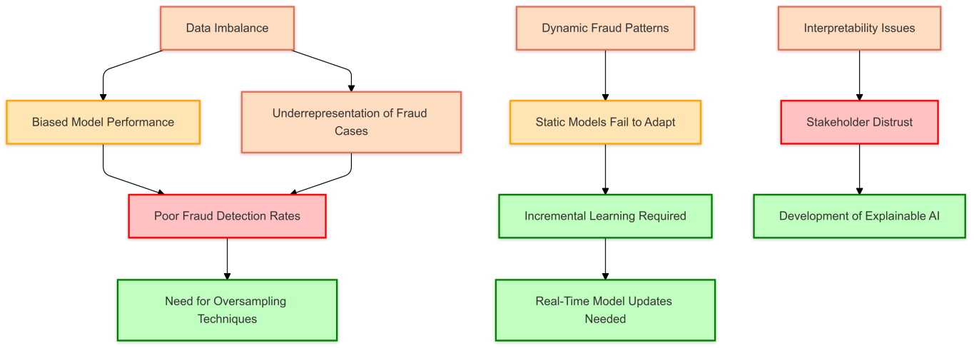

**Fig 3.1 Dynamic Fraud Detection Challenges**

Additionally, current models have no ability to contextualize changing patterns in fraud. Temporal dependencies with contextual nuances often characterize fraudulent transactions, which most traditional ML fails to capture. The long short-term memory (LSTM) networks and even attention mechanisms have been put forward; however, the high computational price and large-scale labeled data create a problem in their implementation.

**3.3 Real-Time Detection Inability**

Real-time fraud detection is a significant gap in current systems. Most of the existing methodologies rely on batch processing where data is analyzed in chunks after it is collected. The delay in detection can cause considerable financial losses and complicates the recovery process. Systems that operate in real time require algorithms efficient enough to process streaming data with high accuracy and low latency.

Scalability is another challenge of real-time systems. Existing models are struggling to scale with the exponentially increasing number of financial transactions. Distributed computing frameworks, as well as parallel processing techniques, have been presented, but their integration with fraud detection models is still in its early stages.

**3.4 Interpretability and Transparency**

The black-box nature of many ML and DL models poses challenges in interpretability and transparency. Tax authorities and financial institutions require clear explanations of why a transaction is flagged as fraudulent. However, advanced models such as neural networks often lack interpretability, leading to resistance in their adoption.

In improvement through SHapley Additive explanations (SHAP), as well as Local Interpretable Model-Agnostic Explanations (LIME), efforts are still at a developing stage. Mostly, these methods give only post-hoc explanations which would likely differ from the internal logic used in the model, thus creating room for low reliability. Therefore, a new pressing need is models which are inherently interpretable with no compromise on performance.

**3.5 Ethical and Privacy Concerns**

The deployment of automated fraud detection systems raises ethical and privacy concerns. Models often require access to sensitive financial and personal data, posing risks of data breaches and misuse. Existing methods lack robust mechanisms to ensure data privacy while maintaining model performance.

Federated learning, which enables model training across decentralized data sources without sharing raw data, has been proposed as a solution. However, its implementation in fraud detection is limited by technical challenges, such as ensuring consistency across decentralized models and mitigating communication overhead.

**3.6 Integration with Emerging Technologies**

This implies that while blockchain technology promises solutions in the areas of enhancing transparency and traceability in fraud detection, integrating ML models is an under-explored area. The decentralized nature of blockchain can complement the technique by providing secure and immutable data storage. Currently, there lacks practical implementations demonstrating the synergy of these technologies.

Similarly, NLP-based techniques to analyze unstructured data for tax documents and financial reports go underutilized. NLP can unveil hidden patterns and anomalies in textual data, allowing for additional insights into fraud behaviors. However, a high amount of computational resource and sophisticated preprocessing techniques are required to blend NLP with traditional fraud detection systems.

The following flowchart summarizes the key research gaps in existing fraud detection methods and their implications.

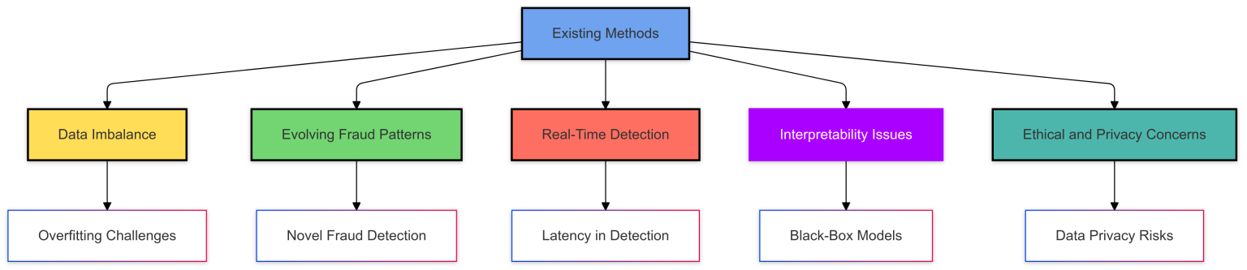

**Fig 3.2 Flowchart Representation of research gaps**

#### 3.7 Future Directions

#### Such research gaps have to be addressed through multidisciplinary approaches. For instance, techniques like federated learning and reinforcement learning are capable of improving adaptability and maintaining privacy in fraud detection systems. The conjunction of blockchain and NLP technologies shall offer new approaches for augmenting transparency in fraud pattern detection. On the other hand, building inherently interpretable models can bridge this gap between performance and interpretability and, by doing that, increase trust among various stakeholders.

While significant research has been conducted in this area, the current practices are not adequate to provide solutions to some of the real challenges like data imbalance and real-time detection, also transparency. It will require team efforts from researchers, practitioners, and policymakers, focusing on collaboration and innovation. This chapter emphasizes the continuing need for research to deliver robust, scalable, and ethics-based fraud detection systems tailored to the needs of evolving financial ecosystems.

**CHAPTER-4**

### PROPOSED MOTHODOLOGY

This is aimed to identify income tax fraud by harnessing the strengths of machine learning and deep learning models. Combining these, the system is designed for high accuracy and adaptability toward the detection of complex patterns in frauds. This proposal addresses significant challenges in class imbalance, high computational complexity, and dynamic evolution in fraudsters' behavior. This chapter outlines the systematic steps that happen in the framework, that is, data preparation, model training, evaluation, and optimization to make the process holistic and efficient. It is a very challenging process as such fraudulent cases in any given dataset are quite less. And also fraud schemes, techniques keep evolving continually and it would not stop by time. For dealing with those problems, the advanced data preprocessing method employed contains techniques such as over- sampling, under- sampling, and generating synthetic datasets for better management of imbalanced class datasets, apart from this feature engineering.

As fraud schemes advance in complexity, so will the need for an adaptive and scalable methodology. In fact, the proposed framework has real-time data processing capabilities and iterative model updates so as to adapt to emerging fraud patterns. This is further complemented with ensuring robust detection of fraudulent activities while maintaining computational efficiency so that it can scale well for large deployments.

The ensemble learning and hybrid modeling techniques improve the detection of subtle anomalies and complex fraud patterns. By balancing the predictive power of the ML algorithms, such as Random Forests and Gradient Boosting, with the deep learning capabilities of the neural networks, the method achieves a balance between precision, recall, and computational performance.

In sum, the proposed method improves not only the accuracy of detection but also presents a scalable and efficient solution evolving in the dynamic nature of fraudulent activities. This framework thus lays a basis for developing intelligent and resilient fraud detection systems in the income tax domain.

### 4.1 Dataset Description

The dataset used in this research is made up of 109,066 records and 14 features, giving a wide range of numerical and categorical attributes to support the fraud detection analysis. Numerical features include critical variables like transaction amounts and account balances that capture the financial details of each transaction. Other features, such as categories like transaction types, times, and locations, add the context necessary for identifying patterns and anomalies. The target variable, isFraud, indicates whether a transaction is fraudulent (1) or legitimate (0), serving as the basis for model training and evaluation. The major issue of this dataset is its imbalanced nature; there are only 0.9% of transactions that are fraudulent. Such a huge difference in class distribution becomes challenging for predictive models, as they tend to be biased toward the majority class, which in this case would be the non-fraudulent transactions. This called for the application of specialized techniques like oversampling (for example, SMOTE) or undersampling and advanced algorithms capable of handling class imbalance, such as Support Vector Machine (SVM) and ensemble methods.

During preprocessing, missing values were noted in important columns such as nameDest, oldbalanceDest, and newbalanceDest.

Missing values imputed using median or mode imputation to ensure consistent data and models could avail of complete information during training. Categorical features also required encoding to make it compatible with machine learning models. One-hot encoding was used to convert the categorical variables into binary vectors, ensuring no loss of inherent information without creating spurious ordinal relationships. Also, the feature diversity in the dataset gave a very strong foundation to detect fraud but had to be preprocessed carefully. Numerical features were normalized to avoid scale-related bias, while feature engineering added more variables like frequency and ratios of transactions to increase accuracy.

This dataset, with all its inherent challenges and characteristics, made it necessary to require robust preprocessing and model selection strategies, which made it a good candidate for the development of advanced fraud detection frameworks.

### 4.2 Model Selection

### It is one of the highly powerful ensembles learning methods that brings together predictions from multiple trees to get accuracy and robust results. Averaging the outputs of several trees reduces chances of overfitting, making Random Forest an extremely reliable performer for fraud detection tasks and capable of processing high-dimensional data plus providing feature importance metrics for pointing out key indicators of fraud. Its versatility allows it to adapt well to different types of datasets, making it a cornerstone of the proposed approach. A Decision Tree is a straightforward and interpretable model that is particularly effective for quick decision-making processes.

Its ability to visually represent decision paths makes it useful for gaining insights into the fraud detection logic. Though prone to overfitting on its own, it is a core component of ensemble methods like Random Forest and Gradient Boosting. The simplicity and speed of the model make it a great fit for an initial screening and fast prediction in fraud detection systems. Support Vector Machine (SVM) is a state-of-the-art gradient boosting algorithm famous for its efficiency, scalability, and capability to handle imbalanced datasets. It ensures that the model performance is optimized at every iteration with weighted updates; hence, it is useful for achieving high precision and recall to detect subtle anomalies in fraud detection tasks. This algorithm also prevents overfitting by regularization, making the use of parallel processing and distributed computing on large datasets feasible and efficient. Autoencoders are generally applied for image data but can be used to classify structured and unstructured data in terms of identifying complex patterns and relationships. Autoencoderss are the best for feature extraction due to automatic learning of deep patterns within the data. Therefore, Autoencoderss are valuable tools in detecting non-linear and latent fraud behaviors. Due to this adaptability, they can deal with a wide variety of representations of data, like transaction records or customer profiles.

Long Short-Term Memory networks are a specific type of Recurrent Neural Network designed particularly for sequential data, like histories of transactions or time-series data. LSTMs learn to capture temporal dependencies and long-term patterns very well and hence are best suited to fraud detection in cases where fraudulent behaviors materialize over time. Because LSTMs hold memory of past inputs, they can detect suspicious trends and activities that might not otherwise come to light in isolated transactions.

These models altogether would cover all aspects of the fraud detection process, be it interpretability, high precision or recall.

### 4.3 Preprocessing Techniques

To ensure the dataset was compatible with the selected models and enhance their performance, a comprehensive series of preprocessing techniques was applied. Missing values, often prevalent in real-world datasets, were handled effectively by employing median imputation for numerical features, ensuring robustness against outliers, and mode imputation for categorical features, thereby preserving their natural distribution. This step ensured the dataset remained complete and usable for all modeling tasks. Normalization of numerical features was carried out using techniques such as Min-Max Scaling, rescaling values to a range of 0 to 1, and standardization (z-score normalization), which centered data around a mean of 0 with a standard deviation of 1. This process proved critical in eliminating biases brought about by features with different magnitudes, thus providing consistent contributions to model performance, especially for distance-based algorithms like gradient boosting. Through one-hot encoding, categorical features were converted into vectors of binary dimensions to facilitate smooth integration into the ML pipeline.

The use of this method ensures that the categorical information does not leak ordinal relationships introduced artificially into the models; to combat the common imbalanced nature of fraud-detection datasets, stratified splitting was used during train-test splitting. This ensured that both subsets contain the same distribution of fraud and non-fraud cases. This is done to evaluate the model in a balanced and representative way. In addition, advanced outlier detection techniques like z-score analysis and IQR methods were applied for the identification and management of extreme values. Such outliers, depending on their impact, either were capped at acceptable thresholds or removed for maintaining the integrity of the data. Feature selection and dimensionality reduction methods such as mutual information analysis and PCA were used for reducing noise, improving computational efficiency, and focusing the models on the most informative predictors. Feature engineering was another important aspect that helped to enrich the dataset by creating new, domain-specific features derived from existing ones, such as transaction frequency, trends over time, and ratios of financial metrics.

This not only improved the representation of complex patterns but also boosted the predictive power of the models.

This preprocessing combination ensured that the dataset was clean, balanced, and optimized for robust training and testing, laying a good foundation for the success of the proposed fraud detection framework.

**4.4 Implementation Workflow**

To handle the computational intensity of the large dataset, a chunk-based processing approach was used, which allows the system to process the data efficiently without overwhelming computational resources. Data partitioning formed the starting point of workflow, where the data was divided into smaller manageable blocks each carrying a constant number of records. It could be 100,000 records per block, for example.

This helped divide the memory and processing requirement for each block to reasonable limits, which in turn ensured smooth execution on big datasets as well.

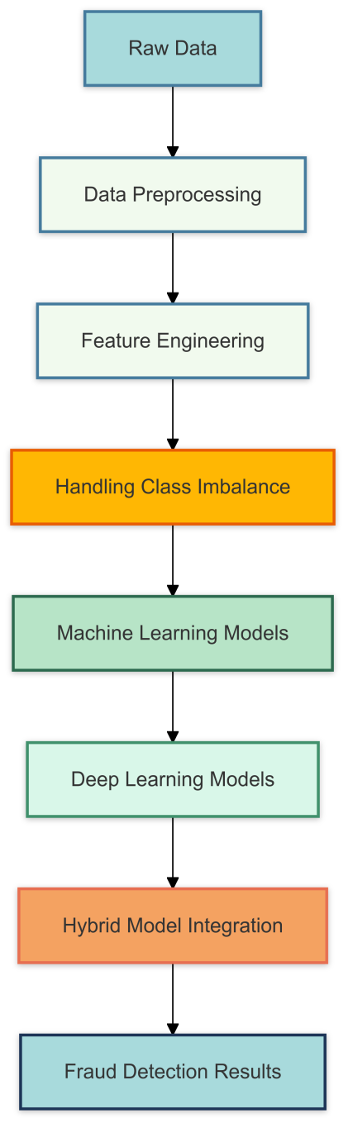

**Fig 4.1 Fraud Detection Workflow**

Once partitioned, the blocks were processed through a process in the following order: preprocessing so as to clean and normalize data to ensure compatibility with the chosen models, followed by training and evaluation of the models on each block. That is, the entire dataset was used without compromising model performance and accuracy due to insufficient resources. Aggregation of results was a crucial step, where predictions and performance metrics from individual blocks were summed up to compute overall metrics, such as precision, recall, and F1-score. This ensured a holistic evaluation of the models across the entire dataset, accounting for potential variability within different chunks. To further optimize the workflow, parallel processing was employed, allowing multiple blocks to be processed simultaneously. This approach utilized multi-core processors and distributed computing environments to significantly reduce computation time and enhance scalability. By processing chunks in parallel, the framework demonstrated its ability to handle large-scale datasets efficiently, making it suitable for real-world fraud detection systems where high volumes of data are common.

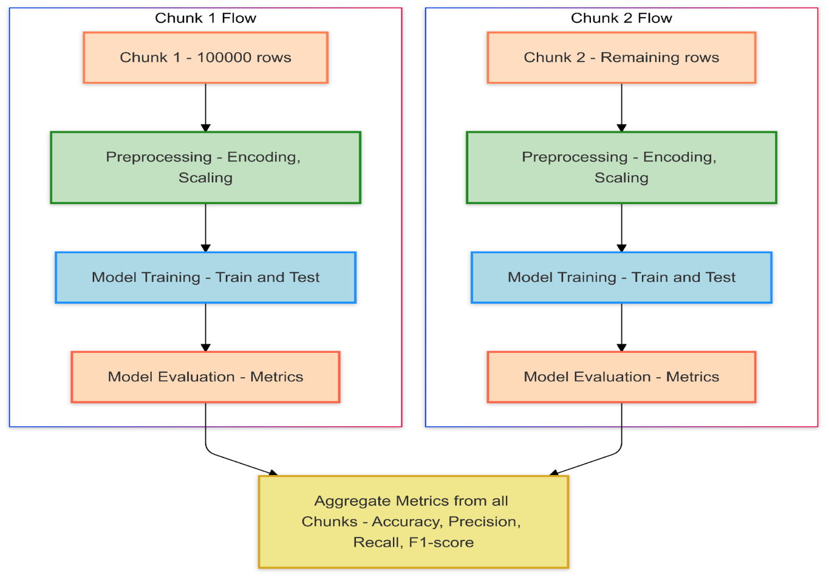

**Fig 4.2 Simplified diagram illustrating the chunk-based processing workflow**

This chunk-based and parallelized approach had several advantages, such as modularity, fault tolerance, and scalability. Isolating computations within individual chunks minimized the risk of catastrophic failure, as errors in one block did not affect the overall process. This modularity also allowed for incremental updates and easy integration of new data, ensuring the adaptability of the workflow to changing datasets and fraud patterns. Overall, this implementation strategy well balanced computational efficiency, scalability, and model performance, making for a robust and practical solution to fraud detection in large datasets.

**4.5 Evaluation Metrics**

The performance of the proposed models for fraud detection has been evaluated using a wide spectrum of metrics that aim toward achieving a balance between efficiency in detection and computational expenses. These metrics have been chosen to evaluate not only a model's ability to classify a given transaction correctly but also towards its effectiveness in picking cases of fraud, which is vital for real-world applications.

In turn, accuracy was used as an overall measure of model performance, reflecting the percentage of correctly classified fraudulent and legitimate transactions. While accuracy is a useful measure, its use can be problematic on large datasets with highly imbalanced class proportions, such as in the dataset used in this experiment. For instance, accuracy of a model that simply identified all transactions as legitimate, due to the predominance of legitimate transactions, does not necessarily indicate the effectiveness of the model in fraud detection.

To mitigate the above drawback, precision and recall are employed as vital metrics.

Precision is calculated as the proportion of true fraudulent transactions to all fraudulent transactions the model flags as fraudulent. Thus, the need for minimum false positives exists. That can avoid several unnecessary investigations and thus unnecessary operational inefficiencies. Meanwhile, the calculation of recall analyzes the proportion of actually fraud transactions as correctly labeled as such by the model. High recall is important so that no fraudulent cases slip through the sieve, even if some false positives have to be tolerated. To balance precision with recall, the F1-score was used as their combined metric, which depicts their harmonic mean. Such a score gives a better estimate of model performance regarding its ability to catch more fraudulent transactions (recall) and ensuring most flagged ones are genuine or true (precision). As the F1-score increases, so does the model with good balance between these critical metrics.

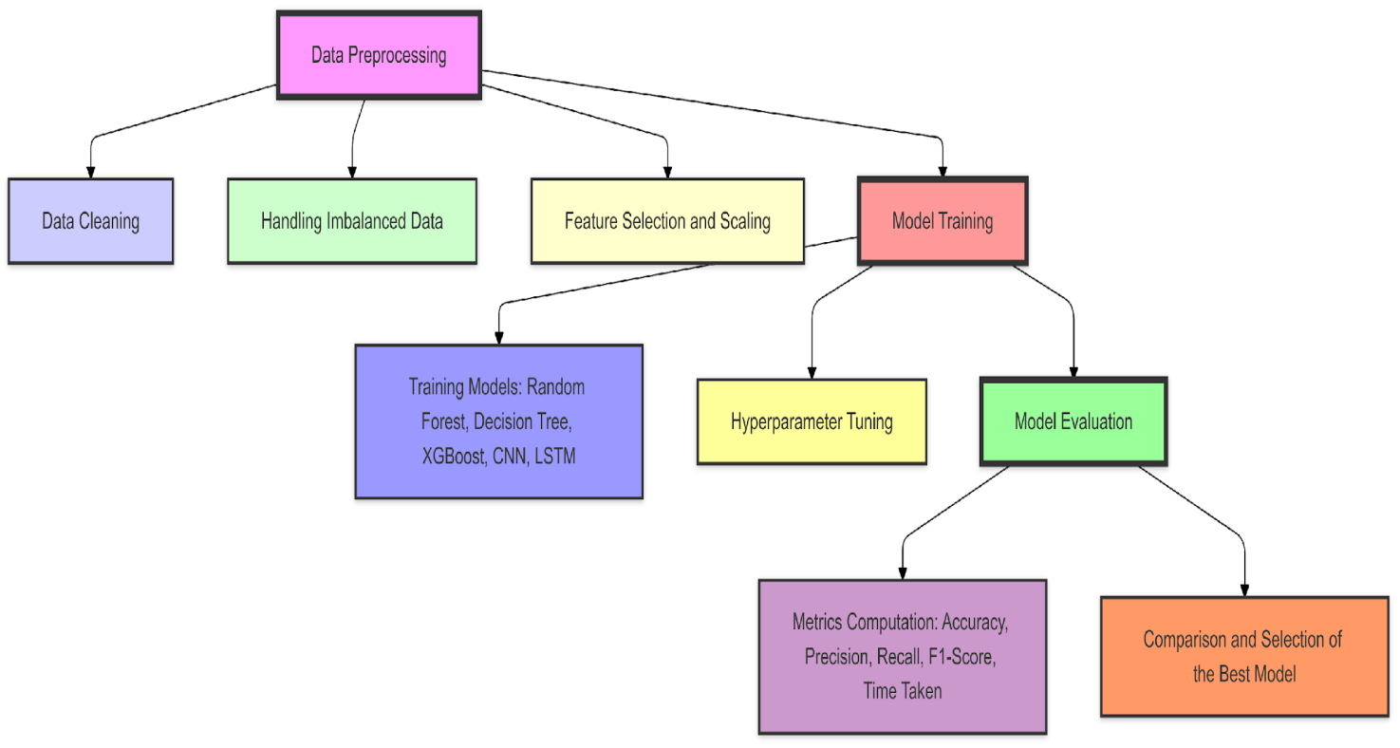

**Fig 4.3 Flowchart illustrating the end-to-end process followed in the research**

The performance in terms of classification, as well as computation time taken by the models, was estimated in order to assess the efficiency of these models. This metric indicates the amount of time taken by the model to process the dataset in both training and inference phases. Computational efficiency is also an important aspect, mainly for large-scale, real-time fraud detection systems in which delays in processing might cause severe financial and operational repercussions.

By analyzing these metrics together, a holistic view of each model's strength and weakness was obtained. For example, models that have high precision but with lower recall were identified as the best choice for cases that involve a higher cost if false positives are incurred while models with higher recall will be prioritized for the case where missing fraudulent cases would incur a severe loss. Furthermore, integration with computational efficiency metrics further ensures the choice is effective not only on performance but scalable as well in real time. Overall, through such an assessment framework, this procedure will arrive at a choice of that model with good fraud-detection accuracy balanced with more practical and necessary constraints based on real-time processing capacity and computing availability.

**4.6 Integrate Techniques of AI**

This fraudulent activity detection framework, therefore, is developed through incorporating new AI techniques in order to ensure increased precision and adaptability of the process for detection. This methodology allows covering both labeled and unlabeled data by the use of a combination of supervised learning, deep learning, and hybrid approaches in order to ensure robust detection of complex dataset’s fraudulent activities.

Supervised Learning was a foundation of the approach. Labeled datasets were used to train models that should be able to classify transactions into fraud or legitimate.

Other techniques used were Random Forest and Support Vector Machine (SVM) for they can handle imbalanced datasets, interpret feature importance, and deliver high accuracy. Random Forest, with its ensemble structure, reduced overfitting by aggregating predictions from multiple decision trees, making it a reliable choice for detecting fraud patterns. Support Vector Machine (SVM), being a gradient boosting algorithm, was particularly efficient in picking up subtle anomalies within the data and handled class imbalances through weighted updates. These models form a strong foundation for determining fraudulent transactions based on historical patterns. Deep Learning techniques were brought in to analyze complex and non-linear relationships within transactional data. Autoencoders (Autoencoderss) are used in order to automatically draw out detailed patterns and spatial relationships that exist in the dataset: for example, correlation in transaction amounts, types, and account balances.

Applying Autoencoders proved invaluable in identifying nuances of fraud behaviors that traditional models would normally miss. Additionally, Long Short-Term Memory (LSTM) networks, a type of Recurrent Neural Network (Recurrent Neural Network), were applied to capture temporal dependencies and sequential trends in transaction histories. LSTMs excelled at analyzing time-series data, making them particularly suitable for detecting fraudulent activities that evolve over time, such as patterns in repeated transactions or account activity. Hybrid Approaches further enhanced the framework by combining supervised and unsupervised methods. These approaches exploited the best of both techniques for the simultaneous analysis of labeled and unlabeled data. For instance, to cluster similar transactions and find data anomalies, one may utilize algorithms such as K-means or autoencoders.

These unsupervised models supplement the performance of supervised models by throwing additional light on fraud instances where there was no clear evidence. By integrating these techniques, the framework achieved a more comprehensive analysis, capturing known fraud patterns as well as emerging, previously unseen behaviors. The integration of these diverse AI techniques ensured that the methodology was not only effective in identifying fraudulent transactions but also adaptable to evolving fraud schemes. By combining the precision and interpretability of supervised learning with the pattern recognition capabilities of deep learning and the exploratory power of hybrid methods, the framework demonstrated its robustness and scalability for real-world fraud detection systems. This multi-faceted approach enabled the detection of complex fraud scenarios, ensuring the framework could adapt to the dynamic and sophisticated nature of modern fraudulent activities.

**4.7 Proposed Innovations**

To overcome the limitations of existing models and enhance the effectiveness of fraud detection, several key innovations are introduced in the framework. These innovations are expected to improve the predictive performance, adaptability, and robustness of the models to the challenges of imbalanced datasets and complex fraud patterns. Hybrid models are an integration which integrates the best of traditional machine learning algorithm algorithms such as Support Vector Machine (SVM) in hybrid architecture models such as convolution neural networks (Autoencoders), Long Short-Term Memory Networks, LSTMs and other architectures. Its merits of being one among the highly accurate models by employing weighted updates and using regularized to handle imbalanced data sets. By integrating it with the ability of deep learning models to recognize patterns, the hybrid approach makes the best out of both methods' strengths.

For example, Support Vector Machine (SVM) efficiently identifies known fraud patterns and important features whereas deep learning models detect the non-linear relationship and underlying trends in the transaction data.

This synergy not only improves overall accuracy but also ensures the detection of both obvious and subtle fraudulent activities, thus providing an all-inclusive solution to fraud detection.

Recognizing that good input data is fundamental, the framework emphasizes sophisticated feature engineering in order to derive meaningful insights from raw transactional data. New features, such as transaction frequency, time-based patterns, changes in account balance, and ratios of transaction amounts to account balances were created to make the model richer in its context. Domain-specific knowledge was further applied to feature extraction such that the reflection of the potential fraud indicators, including sudden changes in transaction amount or unusual location of transactions, is reflected through the features extracted. These engineered features enhance the models' ability to detect complex fraud patterns that may not be evident in the raw data. By enriching the dataset, feature engineering significantly boosts the predictive performance of both machine learning and deep learning models. The inherent class imbalance in fraud detection datasets, where fraudulent transactions represent only a small fraction of the total, poses a major challenge.

To overcome this, the framework utilizes Synthetic Minority Oversampling Technique (SMOTE) to over-sample the minority class. SMOTE generates synthetic samples of fraudulent transactions by interpolating between existing minority class instances. This not only balances the dataset but also enables the models to learn more generalized patterns of fraud, thereby reducing the possibility of overfitting to the small number of original fraudulent cases. Moreover, cost-sensitive learning approaches were applied to assign higher penalties for the misclassification of fraudulent transactions, so the models are improved further regarding their ability to detect rare events. These proposed innovations collectively address the limitations in the current models by making the interpretability and efficiency of traditional machine learning adaptable and providing pattern recognition abilities similar to deep learning. Advanced feature engineering ensures that models receive high-quality input data, while the application of imbalance mitigation techniques helps detect rare fraudulent cases.

All these enhancements ensure a robust, scalable, and adaptive framework for real-world fraud detection systems, capable of evolution along with the changing nature of fraudulent behaviors.

**4.8 Potential Challenges**

Several challenges were expected while implementing the proposed framework for income tax fraud detection: hence, careful planning and innovative solutions would be required. Among all, data imbalance is major; fraudulent transactions are seldom observed, as only a few constitute a minor proportion of the dataset. Consequently, biased models will favor the majority class of such data, and henceforth may produce poor detection rates in relation to fraudulent cases. In an effort to address this problem, balancing the dataset by using techniques like Synthetic Minority Oversampling Technique (SMOTE), cost-sensitive learning methods were adopted to assign a higher penalty for misclassifying a fraudulent transaction.

The second major challenge was the complexity of computation when training deep learning models like Autoencoders (Autoencoderss) and Long Short-Term Memory networks (LSTMs). These models are computationally intensive, requiring high-performance hardware and optimized training processes to efficiently process large datasets. To mitigate this, the framework used chunk-based processing and parallelization strategies that broke down data into smaller, manageable subsets and processed them concurrently. This reduced training time significantly and improved scalability, making the framework feasible for large-scale applications.

Another issue was interpretability of the model, especially when dealing with complex algorithms like Support Vector Machine (SVM) and LSTMs, which are often regarded as black boxes.

The opacity of such models may also be detrimental to the development of trust and understanding from the stakeholders. The incorporation of techniques such as feature importance analysis for Support Vector Machine (SVM) and attention mechanisms for LSTMs made the framework interpretable to some extent and shed light on how the predictions were made. Further, simpler models like Decision Trees are included in the framework that produce results transparently, balancing the level of accuracy with transparency. This methodology for the detection of income tax fraud integrates a comprehensive framework that combines both ML and DL models to effectively address the challenges. This framework has robust preprocessing steps, appropriate model selection, and proper evaluation to achieve accurate, scalable, and efficient fraud detection. Integration of hybrid models, advanced feature engineering, and imbalance mitigation techniques will be used to obtain a balance between performance and practicality. Future work would include further refinement of these models for enhanced detection rates and reduction in false positives, which are very crucial for real-world applications.

**CHAPTER-5**

**OBJECTIVES**

The key aim of this project is to create a technically sound, scalable, accurate, and efficient system to detect income tax fraud. As financial systems are being developed, the sophistication and complexity of fraud schemes are increasing, and thus become difficult for traditional methods of detection to be able to handle. This research uses the combined capabilities of machine learning and deep learning to develop a robust framework that adapts to these complexities, providing a powerful tool for fraud detection. One of the key challenges in detecting income tax fraud lies in accurately identifying fraudulent activities while processing vast amounts of transactional data with minimal computational overhead.

This fraud is usually hidden in vast data, and the fact that its occurrences are rare makes it very difficult to detect. In this research, these challenges are addressed by using high-performance AI techniques that assure a high detection accuracy rate without losing efficiency. It uses scalable methodologies so the system can handle large amounts of data encountered in the real-world financial environments and is thus suitable for large-scale deployment. The objectives of this chapter emphasize the need to strike a balance between accuracy, efficiency, and scalability. Achieving this balance requires a comprehensive approach that encompasses advanced preprocessing techniques, innovative model selection, and rigorous evaluation metrics. The framework aims not only to detect fraud with high precision and recall but also to ensure that it operates within the constraints of available computational resources. It also is capable of changing patterns over time due to the change in fraud patterns. It ensures the relevance and effectiveness of the system over time. This research work becomes a guideline for the construction of sophisticated AI-driven systems that would be capable of enhancing financial security and stability. Addressing the traditional detection technique's limitations, along with ML and DL's strengths, it provides actionable insights and robust solutions to fight income tax fraud. The ultimate aim is to build a framework that can be applied in real-world environments, thus giving governments and financial institutions a reliable tool for safeguarding their systems against fraudulent activities.

### 5.1 Specific Objectives

This research addresses critical challenges in the detection of fraud by design innovative solution that is tuned to today's demands by modern systems of finance. In this regards, the aim is narrowed down to the effectivity performance of ML and DL models optimizes their performances, decreases data imbalances, ensuring scalability and interpretability - all of this with proper alignment to more general scope of developing the robust yet real-time framework for effective fraud detection based on these criteria: high accuracy alongside computational efficiency.

Assess the Effectiveness of ML Models : The core aim is the assessment of the performance of traditional models like Random Forest, Decision Tree, and Support Vector Machine (SVM) for the purposes of detection of fraudulent activities. These models are assessed to assess their adequacy for managing structured financial data and also in tracing patterns of fraudulent activities which might not easily be known. It attempts to research whether they might identify less visible signs of frauds but in efficient computation. Based on these analyses, this paper discusses the strengths and limitations of these models toward identifying whether they are really viable in real-world applications, like fraud detection. The study then analyzes the Role of DL Models: Deep learning models can learn and identify sophisticated patterns associated with fraudulent activity.

Advanced architectures such as Autoencoderss and LSTM networks are investigated for their ability to analyze sequential data and detect sophisticated fraud schemes. The research determines the effectiveness of these models when applied to large-scale datasets with structured financial information. The study also investigates their adaptability to changing fraud patterns, thus ensuring relevance in dynamic financial environments. Optimize Model Performance: The parameters of the both ML and DL models are fine-tuned with the best performance based on the key metrics such as accuracy, precision, recall, and F1-score. The research is done in a comparative analysis of different models to identify those which give the best trade-off between performance and computational efficiency.

This step is more critical for real-time applications, where the system must process large volumes of data in a quick turnaround time without losing accuracy. More fine-tuning techniques through the application of hyperparameter techniques like grid search and Bayesian optimization are applied to further perfect the models. Overcoming Class Imbalance in Fraudulent Datasets: There are many fraud detection datasets where class imbalance is really pronounced, with fraudulent transactions representing a small percentage of the overall data. This research employs techniques such as Synthetic Minority Oversampling Technique and cost-sensitive learning approaches to address this challenge. These methods are focused on balancing the dataset and improve the ability of the models in fraud case detection.

In addition, the study explores the impact of these techniques on model performance, in terms of the improvement achieved in fraud detection rates and overall reliability. Develop a Scalable Real-Time Solution: Scalability as well as real-time response is crucial for the implementation of fraud detection systems in any modern financial environment. A system that can process large quantities of data without compromising precision is designed and implemented with the research. Parallel and distributed computing strategies are devised to enhance the scalability and reduce the processing time of the system. This research addresses practical requirements in the detection of fraud in dynamic and high-volume environments by ensuring that the framework is capable of real-time analysis.

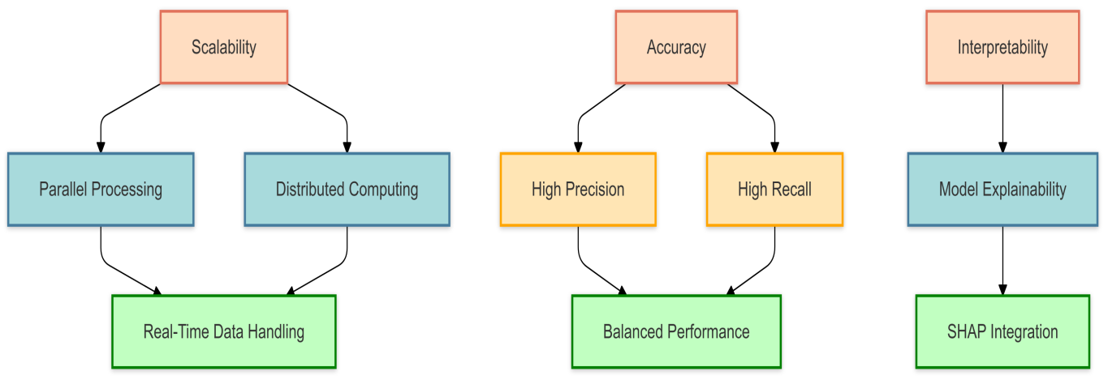

**Fig 5.1 Real-Time Fraud Detection System Objectives**

Enhance Model Interpretability: Interpretability is a key objective, as it fosters trust and understanding among stakeholders. The research integrates explainability frameworks, such as SHapley Additive explanations, to make model predictions more transparent. These frameworks provide actionable insights into the factors contributing to fraud detection decisions, helping users understand the rationale behind each prediction. By improving model interpretability, the study ensures the framework is not only accurate but also trustworthy and user-friendly.

The research work lays the foundation for the development of sophisticated AI-driven fraud detection systems by meeting these objectives. The solutions proposed here are robust, scalable, and adaptable enough to ensure effectiveness in real-world financial scenarios in combating sophisticated fraud schemes.

**5.2 Broader Implications**

Beyond the specific scope of this particular study, its objectives hold significant implication in terms of enhancing security over financial resources, advancing further research, and also providing insight into policy or implementation directions. Through accurate, efficient, scalable, and fraud detection, the research contributes directly towards stabilizing and securing any given financial system. Fraudulent activities, with regard to economic integrity, mean money losses, trust loss, and public loss of confidence in financial institutions. Proposed methodologies will be beneficial tools for tax authorities and financial institutions in fraud prevention and detection of transactions within their systems. This also helps to ensure the long-term application of such systems in addressing evolving fraud schemes, further strengthening financial systems against sophisticated threats. Methodologies and findings of this study can be considered a good base for further research in fraud detection and related fields.

In conclusion, this research analyzes the strengths and weaknesses of different ML and DL models to identify key areas that need further improvement and innovation. The new approaches to tackle the complex fraud patterns have been inspired through insights on the performance of hybrid models and advanced feature engineering techniques. Addressing class imbalance and computational efficiency challenges are also underlined by the study and thus guides researchers to the development of more robust and practical solutions. Explainability frameworks integration further opens the avenue to enhance model transparency and trust, pointing toward an important area of future exploration and refinement. The results of this study support the creation of policies and strategies for the implementation of AI-driven fraud detection systems in financial institutions and tax authorities. The effectiveness of ML and DL models, as shown by the study, makes a strong case for the inclusion of advanced technologies in the framework of financial fraud prevention.

The policymakers can utilize these findings to design regulatory guidelines and promote scalable, real-time fraud detection systems. The emphasis on interpretability and transparency in AI systems encourages ethical standards and best practices to deploy them responsibly. Through the intersection of technical innovation with the practical implementation that such studies provide, this research not only challenges the urgent issues but lays a better foundation for the security of a more technologically advanced financial ecosystem.

### 5.3 Key Challenges Addressed

The research addresses several critical challenges in fraud detection, focusing on the practical and technical aspects required to create an effective and deployable system. One of the most significant challenges is scalability, particularly when dealing with large datasets that may include millions of transactions. This research focuses on developing methodologies that can process large volumes of data in an efficient manner so that the proposed system can provide results within minimal time. This is a crucial factor for real-time fraud detection applications. Class imbalance poses another significant challenge since fraudulent transactions often constitute only a small fraction of the dataset.

This imbalance may result in biased models that cannot identify fraudulent cases correctly. The study utilizes techniques like Synthetic Minority Oversampling Technique for the augmentation of the minority class and cost-sensitive learning approaches that penalize the misclassification of fraud cases. These are strategies intended to improve the models' ability to detect fraud without compromising overall accuracy. The second aspect of concern is the area of computational complexity since, with the deployment of very sophisticated models in real applications, there is an appeal for high computational efficiency. It investigates methods of ensuring computational performance of machine and deep learning models remain valid for both effectiveness and feasibility for large-scale and real-time applications. The study employs parallel processing and optimization techniques to minimize the process time without loss of precision in detection. Interpretability is an essential consideration because, more or less, black boxes black box deep learning architectures when they function.

Transparency can affect the degree to which stakeholders can trust the model and the acceptance to be made in that use case.

In that line, the study underscores explainability in the models whereby tools such as SHAP are integrated for a reasonable explanation of what is really influencing the prediction made from the model. By enhancing interpretability, the study aims to foster greater trust and usability of these models in real-world financial systems. These strategies together form a comprehensive approach to overcoming the challenges of fraud detection, ensuring that the proposed framework is scalable, effective, efficient, and transparent.

### 5.4 Proposed Innovations

It will introduce innovative methodologies that focus on improving fraud detection using approaches in hybrid modeling, feature engineering, and real-time deployment. Such efforts target overcoming existing shortcomings in the current systems used in fraud detection in delivering a strong, scalable, and accurate framework for such applications that is robust in handling dynamic fraudulent activity patterns.

The hybrid modeling approach brings together the strengths of machine learning and deep learning techniques for improved accuracy and robustness. ML models, like Random Forest and Support Vector Machine (SVM), are known for their interpretability and efficiency in dealing with structured data, while DL models, such as Autoencoders and LSTM networks, are good at capturing complex, non-linear patterns and temporal relationships. By integrating the best features of both approaches, the hybrid model ensures comprehensive analysis, enabling the detection of both obvious and subtle fraud patterns. This combination not only improves detection performance but also enhances the system’s adaptability to evolving fraud schemes. Advanced feature engineering plays a critical role in enhancing the quality of inputs for the models.

Developing new feature extraction techniques is aimed to design new attributes that bring a deeper understanding of transactional behavior. Transaction frequency, time-based patterns, and dynamics in account balance are engineered features that draw out the possible indicators of fraud. Enriched inputs facilitate better detection of anomalies through the models, leading to an improvement in performance and reliability overall. The focus on advanced feature engineering also ensures that the system could leverage domain-specific knowledge for further refinement of predictive capability. Real-time deployment forms a major objective of research, as it answers the need of practical applications for systems in live environments. The proposed framework is designed to process and analyze large datasets efficiently and provide real-time fraud detection capabilities.

It makes use of techniques like parallel processing, distributed computing, and optimized model architectures for scalable systems with low latency. The real-time capability has been a requirement in today's financial systems, where detecting frauds and responding quickly helps in saving economic losses and the resultant erosion of trust. This research provides the foundation for advanced fraud detection systems that are efficient, accurate, and suitable for real-world challenges using hybrid modeling, advanced feature engineering, and real-time deployment strategies. The proposed methodologies increase the technical performance of the system while addressing the operational needs of deploying fraud detection solutions in dynamic and high-volume financial environments.

### 5.5 Summary

The objectives that are covered in this chapter lay the groundwork for an all-encompassing approach toward deriving meaningful outcomes from research into fraud detection. With evaluation of diverse models, the overcoming of some critical dataset challenges such as class imbalance and missing values, and making sure scalability to real-world applications, this study aims to contribute much to the domain of income tax fraud detection. These efforts are channeled toward building technically robust yet practical frameworks for implementation in financial systems. These researches are designed towards providing solutions that are not only technologically efficient but also actionable for stakeholders in the financial sector.

The proposed methodologies manage to balance accuracy, computational efficiency, and scalability to address key needs of modern fraud detection systems. The study focuses on real-time applicability, meaning that the proposed solutions are capable of handling dynamic fraudulent activities and large amounts of data common in financial transactions. Additionally, the incorporation of interpretability frameworks ensures that the solutions are clear and trustworthy, leading to greater adoption by stakeholders. This research sets the stage for the future progression of AI-driven fraud detection systems in tacking the most crucial challenges and proposing innovative approaches. By integrating advanced machine learning and deep learning techniques with scalable and explainable frameworks, the study not only addresses current limitations but also establishes a roadmap for continued advancements in the field.

**CHAPTER-6**

**SYSTEM DESIGN & IMPLEMENTATION**

The system design and implementation chapter gives an overview of the architectural framework, core components, and systematic steps carried out to achieve the goals of this research. The focus of this chapter is developing a scalable and efficient fraud detection system by integrating ML and DL models. This elucidates the system architecture, preprocessing as well as handling of the data, processes involved in feature engineering, and ways to deploy models successfully in real-world applications. Building a strong pipeline is thus more focused, capable enough to handle big data yet to be as accurate as possible and scalable.

The architectural framework has been conceptualized to cater to all the challenges that exist in fraudulent detection, including computational complexity and class-imbalance problems. Techniques such as optimization of data processing algorithms and balancing methodologies like Synthetic Minority Oversampling Technique and cost-sensitive learning have to be implemented to ensure accurate detection of rare fraudulent transactions without being overwhelmed by the dominant legitimate transactions. It further mentions the essence of feature engineering, advanced techniques on raw datasets to extricate meaningful features. Among such techniques include transactional patterns of a customer and time based behavior and their trends along account activities in which there will be enhancements of ML and DL's input, and thus making the two predictive models become better.

This is further made computationally efficient by paralleling their processes and processing in high frameworks of data volumes inherent in financial transactions. Finally, it outlines the strategies for deployment of the models developed, such that they do not just theoretically work well but practically too. It considers factors such as fraud detection capability in real-time, seamless integration with any existing financial system, and the ability to have explanations of frameworks that could further enhance trust and transparency within decision-making processes. Addressing these points will make up the next chapter toward having a very powerful, adaptive, and efficient system responding to demands of modern environments.

### 6.1 System Architecture

The architecture of the fraud detection system is designed as a modular framework, with each component serving a specific, independent function to streamline the detection process. This modularity ensures scalability, efficiency, and adaptability, allowing the system to address the unique challenges of fraud detection.

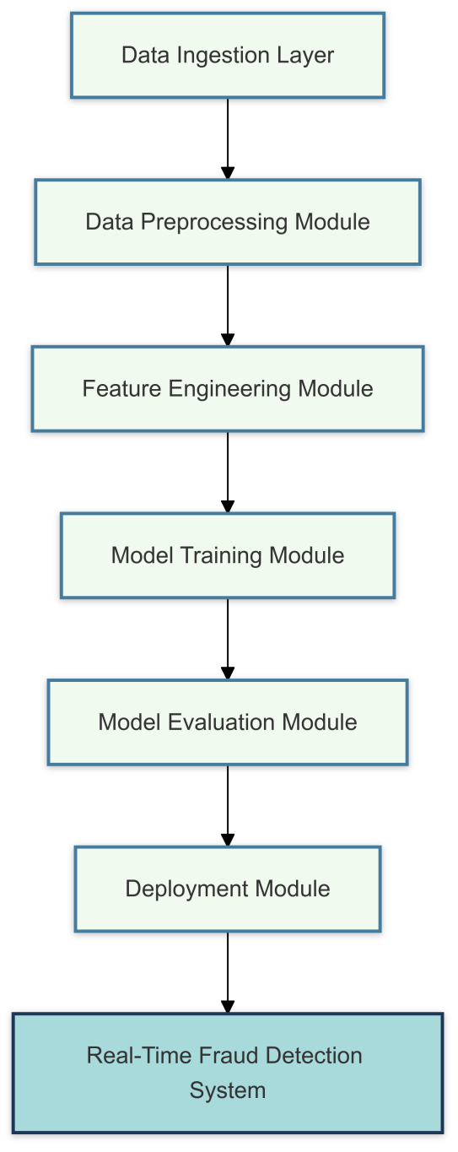

**Fig 6.1 Modular Architecture for Fraud Detection**

The essential components of the system are described below:

#### 6.1.1 Data Ingestion Layer

This layer of the fraud detection system is focused on managing the input data, preparing and optimizing it for further analysis and model training. The main focus is on the efficient and effective handling of raw transactional data, which involves dataset loading and chunking processes.

Dataset Loading is the first step in this layer and involves ingesting raw transactional data from various sources. It accepts different formats such as CSV files, relational databases, and real-time data streams. At this stage, missing values in key columns are imputed by imputation techniques, which may be median imputation for numerical features or mode imputation for categorical features. Numerical features are normalized to bring them into a consistent range, like 0 to 1 or standardized around a mean of 0, so that features with larger scales do not dominate the models. These preprocessing steps clean and make the dataset consistent for further analysis. Chunking is used to handle the computational intensity associated with the processing of large datasets.

The raw data is divided into smaller, manageable chunks with a predefined number of records in each chunk. It not only increases the efficiency of processing but also ensures that resource constraints, like memory constraints, do not impede the performance of the system. Chunking is especially valuable in real-time systems, since it allows for parallel processing: multiple chunks can be handled simultaneously, significantly reducing the overall computation time. This modular processing of data chunks facilitates scalability and ensures that the system can adapt to growing volumes of transactional data without compromising accuracy or efficiency. Together, dataset loading and chunking form the foundation of the input data layer, ensuring that raw transactional data is cleaned and processed efficiently. These processes are crucial for maintaining the system's scalability, accuracy, and readiness for real-world applications.

**6.1.2 Feature Engineering Module**

This module focuses on extracting and transforming features from the raw dataset in order to improve the performance and accuracy of fraud detection models. Advanced preprocessing and augmentation techniques ensure that data is well-prepared for ML and DL models. The key steps in include one-hot encoding, feature scaling, and synthetic data generation.

One-Hot Encoding is used to transform categorical variables into binary vectors, making them compatible with ML and DL algorithms.

This step ensures that the categorical variables, such as transaction types or regions, are represented in a manner that preserves their informational value without introducing artificial ordinal relationships.

For instance, the categorical feature "Transaction Type" with values {Transfer, Payment, Withdrawal} will be transformed into binary columns {Transaction_Transfer, Transaction_Payment, Transaction_Withdrawal}. It allows categorical feature encoding in a model; hence, feature scaling entails normalizing the numerical features. Numerical feature ranges into fixed limits so that values between 0 and 1 scale them, and standardizing to mean at 0 and a standard deviation of 1 keeps huge ranges and magnitudes for features, like transaction amount or account balance, from driving the model's learning. Feature scaling helps to improve the rate of convergence of gradient-based optimization algorithms and enhance performance by bringing all the features on the same scale. Synthetic Data Generation addresses the problem of class imbalance specific to fraud detection datasets where fraudulent transactions form a minority number in the data. Generation of synthetic samples of minority class fraudulent transactions is carried using techniques like Synthetic Minority Oversampling Technique (SMOTE). SMOTE creates new instances by interpolating between existing minority class samples; this will increase the representation of those classes in the dataset. This step helps the models learn more generalized patterns of fraud, increasing their ability to detect rare fraudulent cases and reducing bias towards the majority class.

Together, these steps constitute a very strong feature engineering pipeline; the data will be enriched, balanced, and standardized before feeding it into the models. This module serves as a critical component in enhancing the predictive capability of the fraud detection system to pick up complex patterns and anomalies in transactional data with accuracy and reliability.

**6.1.3 Machine Learning and Deep Learning Models**

The fraud detection system integrates a diverse set of models, each selected for specific strengths in addressing different aspects of the detection process. Combining traditional machine learning algorithms with advanced deep architectures ensures that the system approaches the detection of fraudulent activities as comprehensively and effectively as possible. The models added to the system are as mentioned below: Random Forest is a strong and interpretable machine learning model that has great strength in handling structured data.

Its ensemble approach is based on the aggregation of predictions from multiple decision trees to enhance accuracy and minimize overfitting.

Random Forest offers feature importance metrics, which provides insights on which variables most significantly influence the detection of fraud.

This interpretability makes it useful for understanding the decision-making process and building trust among stakeholders.

Also, it is suitable for high-dimensional large datasets and, therefore, a reliable choice for initial fraud detection tasks.

Support Vector Machine (SVM) is one of the most popular state-of-the-art gradient boosting algorithms. It is famous for its high accuracy and efficiency, especially when used on structured data. Its iterative learning process enables it to capture subtle patterns and interactions between features, making it highly effective for fraud detection. The technique Support Vector Machine (SVM) incorporates regularization techniques for not overfitting. Being highly computationally efficient, the algorithm will easily scale for handling larger data sizes. This model plays an essential role in pinpointing nuanced fraudulent behaviors that are prone to being overlooked by a simplistic model. Two of the incorporated deep learning architectures that go into detecting intricate patterns from transactional data include Autoencoders and LSTMs. Autoencoders are good at automatically extracting spatial and hierarchical patterns, which makes them suitable for identifying relationships between features, such as correlations between transaction types, amounts, and times.

LSTMs are designed for sequential data and are good at capturing temporal dependencies and trends in transaction histories. They are particularly useful for detecting evolving or sophisticated fraud schemes that unfold over time. Together, Autoencoders and LSTMs improve the system's ability to track complex patterns and offer deeper insights into fraudulent behavior. By integrating Random Forest and Support Vector Machine (SVM) with Autoencoders and LSTMs, the system leverages strengths from traditional machine learning coupled with advanced deep learning capabilities in a multi-model approach with robust performance in handling divergent fraud scenarios with high precision, efficiency, and adaptability to real-world financial ecosystems.

**6.1.4 Evaluation and Feedback Loop**

This module deals with evaluating the performance of the models implemented in the fraud detection system. Critical feedback for further optimization and fine-tuning can be availed of by studying key metrics in relation to its operational peak efficiency and accuracy. The models are to be considered from both angles: their predictiveness and computation efficiency, such that the demands of real-world applications are met. Some of the major metrics used in this module are: Accuracy measures the overall correctness of the model by computing the percentage of both fraudulent and non-fraudulent transactions that are classified correctly. Accuracy is a very basic metric, but it may be misleading for highly imbalanced datasets, where the majority class dominates. So, it is complemented with other measurements to give a more comprehensive assessment. Precision calculates the percentage of transactions which a model has labeled as fraud that are actually fraudulent. Good precision means the model minimizes false positives and it is an important characteristic for minimizing extra investigations and operation cost incurred by stakeholders. Recall shows how well the model could discover actual fraudulent transactions in terms of percentage of cases frauded.

High recall is critical in avoiding false negatives and ensuring that fraud is not undetected.

Fraud detection often involves a trade-off between precision and recall.

F1-Score is the harmonic mean of precision and recall, which gives a single measure balancing the trade-off between the two measures.

This is particularly useful in fraud detection, where both false positives and false negatives carry heavy consequences.

High F1-score means that the model maintains strong precision and recall performance simultaneously. Computational Time refers to the efficiency of the model to process data, including the training and inference phases. This metric is critical in real-time fraud detection systems, where rapid processing must be achieved for timely identification and response to fraudulent activities. Models with low computational time are preferred for deployment in scenarios requiring high throughput. The module identifies the strengths and weaknesses of each model by analyzing these metrics collectively. This feedback loop ensures that the system not only achieves high predictive accuracy but also remains efficient and scalable, meeting the operational demands of modern financial environments.

### 6.2 Data Flow Diagram

The design of fraud detection data flow aims at the systematic transformation of raw transactional data into meaningful and actionable insights, organized through a series of interdependent and structured steps, with each step being optimized to ensure scalability, accuracy, and real-time processing. Such expanded description of the detailed steps is as follows

**Data Input**: It starts with the raw ingestion of transactional data coming from various sources. Examples include financial databases, CSV files, API streams, or real-time feeds. The input contains both numerical attributes, for instance, transaction amounts, and account balances, and categorical attributes, such as the types of transactions and the region. The system supports the modes of batch and streaming ingestion of data to allow both historical and real-time transactions. Input data is also validated with respect to consistency, completeness, and adherence to formats expected.

**Preprocessing**: The raw data undergoes the cleaning, transformation, normalization, and cleaning process of data for its suitability with analysis.

Missing values in the data are handled with imputation techniques such as median replacing for numerical data or mode replacing for categorical data. Outliers in numerical features are identified and either capped or removed based on statistical thresholds, such as Z-scores or interquartile ranges. Features are normalized using Min-Max scaling or standardization so that all numerical attributes have uniform ranges. Categorical variables are encoded into binary vectors through one-hot encoding to be compatible with ML and DL algorithms. The class imbalance is addressed in the preprocessing step by using techniques such as weighted cost-sensitive methods to enhance the representation of minority fraud cases.

**Feature Engineering**: Feature engineering involves extracting meaningful attributes from the raw dataset to improve the predictive performance of the models. This step includes creating derived features, such as transaction frequency, historical trends, and ratios (e.g., transaction amount to account balance).

Also, domain-specific features add on board to pick upon slight subtlety behaviors during transaction, flags with anomalous timings for such a transactions, geography and unusual shift in expenditure etc. Now, this method can leverage feature selection algorithm with high-order algorithms which retain highly relevant ones thereby excluding redundant and filtering noise into improved efficiency with the model. This involves breaking up the preprocessed and feature-engineered data into train, validation, and testing subsets. Machine learning-based models, such as Random Forest and Support Vector Machine (SVM), are trained over this subset to identify any discernible pattern in fraudulent activities. Similarly, deep learning-based models like Autoencoders and LSTMs are applied on top of the other machine learning models to find deeper relationships and temporal dependencies that are not easily determinable with machine learning algorithms alone.

Cross-validation techniques are used to ensure the generalization of models in unseen data. Hyperparameter tuning is performed using the best possible performance metrics like accuracy, precision, recall, and F1-score, which are achieved with methods such as grid search or Bayesian optimization.

**Fraud Prediction**: Trained models are deployed in the system's inference engine, analyzing incoming transactions. It predicts the probability of the transaction being fraudulent for every transaction. Transactions that carry high fraud risk are highlighted for further review or direct intervention depending on the operational requirement. The prediction is optimized to provide low latency and high throughput, enabling real-time fraud detection in high volume environments. Evaluation and Feedback: The performance of the system is monitored by using periodic evaluation metrics, such as accuracy, precision, recall, F1-score, and computational time. They are critical in determining flaws in the system and hence ensuring that the system performs within standard benchmarks. The feedback incorporates newly labeled transactions, in this case, confirmed cases of fraud, into the training dataset to enable it to learn from recent patterns and adapt with emerging fraudulent patterns.

This iterative process improves the adaptability and robustness of the system.

**Continuous Learning and Optimization**: After its initial deployment, the system is designed for continuous improvement. Automated pipelines periodically update models with fresh data for them to be effective on the evolving schemes of fraudsters. Techniques such as model pruning or lightweight architecture adaptations may be applied for maintaining the computational efficiency of the machine without sacrificing its accuracy. Feedback from domain experts and stakeholders is also integrated for refining both the data pipeline and the decision-making process. This comprehensive data flow ensures that the fraud detection system is not only accurate and efficient but also adaptive and scalable, capable of addressing the ever-changing landscape of fraudulent activities in modern financial environments.

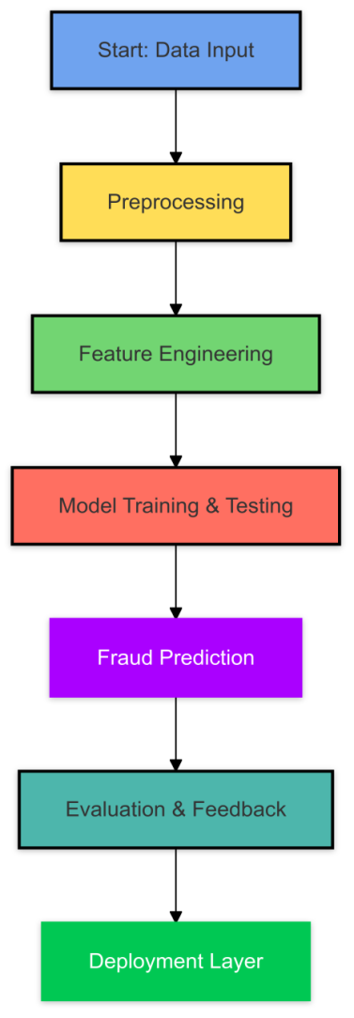

**Fig 6.2 Dataflow Diagram**

### 6.3 Implementation Steps

The fraud detection system implementation starts with data preprocessing, the core step to prepare the raw transactional data to analysis. This includes cleaning the data where missing values are addressed through imputation techniques, normalizing the numerical features to bring it to a standard range, and encoding categorical variables to numerical formats using methods such as one-hot encoding. It gives pre-processed information from different sources to make sure data is clean, consistent and compatible with the ML and DL, which acts as a powerful root base for subsequent processes. And after preprocessing, the whole system proceeds with training and testing where prepared data can be divided into training as well as testing subsets. Machine learning models such as Random Forest and Support Vector Machine (SVM), along with deep learning architectures like Autoencoders and LSTMs, are trained on the training data to identify patterns indicative of fraud. These models are then validated on the testing data to determine their performance in terms of accuracy, precision, recall, and F1-score. This iterative process of training and testing ensures that the models are fine-tuned to perform optimally. In this way, the fraud detection becomes accurate and efficient.

**6.3.1 Data Preprocessing**

This step, in a way, plays a critical role by ensuring that the transactional data is clean and of consistency while making it compatible enough to prepare raw data for analysis into machine learning (ML) and deep learning (DL) models. This leads to improved quality of the input data while also enhancing the models to better handle issues including missing values, inconsistent scales, and categorical data, which is addressed in preprocessing pipelines, with the following critical key processes included:

Missing Values Handling is the first step in cleaning the dataset.

Missing entries can occur in critical fields such as transaction amounts, account balances, or transaction types due to data collection errors or system inconsistencies. These gaps are addressed using imputation techniques. For numerical features, missing values are typically filled with the mean or median of the respective column to maintain the overall distribution and avoid the influence of outliers. For categorical features, missing entries are replaced by the mode, so that the most common category is preserved. This process prevents data loss and ensures that the dataset remains comprehensive for subsequent analysis. Applicating normalization in case of numerical attributes to adjust its values onto a fixed scale, so that these lie in range 0 to 1 through min-max normalization or lie between mean equals to zero and standard deviation equals to 1 due to z-normalization; this prevents very wide-scale numerical ranges, say like transaction values or accounts.

Normalization also enhances the convergence rate of optimization algorithms in ML and DL models, thus making training faster and the overall performance better. Encoding categorical data transforms categorical features into numerical representations compatible with ML and DL algorithms, which usually take numerical inputs. One of the most common methods used is one-hot encoding, where each unique category is converted into a binary column. For example, the categorical feature "Transaction Type" with values {Transfer, Payment, Withdrawal} will be represented by three binary columns: "Transaction_Transfer," "Transaction_Payment," and "Transaction_Withdrawal." Such encoding allows the models to interpret categorical information appropriately, avoiding spurious ordinal relationships.

Beyond these steps, depending on the nature of the data, further pipeline techniques could include outlier detection and removal, feature scaling, and dimensionality reduction. All these preprocessing steps will help in ensuring the data is clean, well-balanced, and properly structured so that good models for detecting frauds are developed. The pipeline of preprocessing greatly contributes to the overall system's efficiency and reliability by correcting anomalies and enhancing data quality.

|  |  |  |
| --- | --- | --- |
| **Technique** | **Purpose** | **Implementation Details** |
| Missing Value Imputation | Handle incomplete datasets | Median imputation for numerical features; mode for categorical |
| One-Hot Encoding | Encode categorical variables | Converts categories into binary vectors |
| Normalization and Scaling | Standardize numerical data for ML models | Min-Max scaling to range 0-1; z-score normalization |
| SMOTE (Synthetic Oversampling) | Balance class distribution in imbalanced datasets | Generates synthetic samples for minority classes |
| Outlier Detection | Identify and manage extreme values | Z-score analysis and IQR methods |

**Table 6.1 Preprocessing Techniques**

**6.3.2 Training and Testing**

The actual implementation of the fraud detection system is based on some critical steps starting with the splitting of the dataset. This will split the data into training and testing subsets in such a way that the original class distribution is preserved. To this end, stratified sampling is employed to ensure that the proportion of fraudulent and non-fraudulent transactions in both subsets mirrors the overall dataset. This approach is important especially for imbalanced datasets because it ensures the testing subset does not contain more of the majority class to facilitate fair model performance evaluation.

Model Development uses the training set. Testing is left to verify whether the model is generally capable of working with unknown data, and that is why this task is carried out with the testing set.

Once the data is split, the next step is the training of models. Training of ML and DL on preprocessed data occurs. The focused ML models are Random Forest and Support Vector Machine (SVM), which will be trained to capture any relationship between input features and the target variable in a structured data set. In parallel, DL architectures such as Autoencoders and Long Short-Term Memory networks are used to identify complex patterns and temporal dependencies in the data. The training process is on feeding the models with labeled data, which allows the models to learn fraud patterns effectively. This phase is iterative; models progressively refine their weights and parameters to improve the predictive accuracy. To achieve the best model performance, the implementation involves hyperparameter tuning.

Hyperparameter tuning optimizes the model parameter configuration to obtain the best trade-off between accuracy and computational efficiency. Techniques used include grid search and random search to systematically explore a range of parameter values such as learning rates, tree depths, or the number of neurons in a DL architecture. The process also checks into the parameters like precision, recall, and F1-score, which ensure the tunable model will work well according to many other criteria for evaluation. After optimizing those parameters, tuning the hyperparameters minimizes overfitting and over-fitting risks by boosting predictive capabilities in models. Together, these steps form a structured pipeline to transform raw data into actionable insights. Dataset splitting will ensure robust evaluation, model training builds the predictive capabilities, and the system fine-tunes via hyperparameter tuning for actual-world performance. These procedures all combine to form a strong basis for a reliable, scalable, and efficient fraud-detection system.

**6.4 Challenges Encountered**

### Several critical challenges had to be overcome to make sure the system is effective and scalable for real-world applications, and thus it had to be designed and implemented to overcome them. Several targeted solutions were incorporated within the system's architecture and processes to overcome these problems.

One of the important challenges is class imbalance wherein fraudulent transactions constitute only a small fraction of the total dataset. Without this balance, models can become biased toward the majority class, leading to poor detection rates for fraudulent cases. SMOTE generates synthetic samples of the minority class by interpolating between existing instances, enhancing the representation of fraudulent transactions in the dataset. This helps the models be trained on more balanced datasets, and by extension, improves the possibility of effective identification of rare cases of fraud. Computational efficiency was also an issue. Given the size of transactional datasets and deep learning models' computational intensiveness, this had become an issue.

This chunking was used where a big dataset was broken up into smaller, more processable units. The reduction of overhead memory also allowed for chunking, which enabled the processing of multiple chunks concurrently, thereby reducing processing time substantially and thus capable of handling large volumes of data. This made the system ideal for real-time fraud detection applications. Model interpretability was also a pressing concern since complex models, such as deep learning architectures, often function as "black boxes," making it hard to understand their predictions. To this end, the system incorporated explainability frameworks like SHapley Additive explanations (SHAP).

SHAP clearly shows how each feature contributes to a model's predictions. This makes stakeholders have a transparent view of why certain transactions are flagged as fraudulent. The interpretability builds trust in the system and helps in identifying actionable insights for decision-making. By addressing these challenges—class imbalance, computational efficiency, and model interpretability—the system design ensures that the fraud detection framework is both robust and practical, meeting the demands of dynamic financial environments while maintaining accuracy and transparency.

|  |  |  |
| --- | --- | --- |
| **Challenge** | **Description** | **Proposed Solutions** |
| Data Imbalance | Fraudulent transactions form a small fraction of the dataset, leading to biased models. | Use SMOTE for oversampling; cost-sensitive learning |
| Dynamic Fraud Patterns | Fraud schemes evolve over time, making static models ineffective. | Implement incremental learning and model updates |
| Computational Complexity | High resource demands for training deep learning models on large datasets. | Employ chunk-based processing and parallelization |
| Interpretability | Advanced models (e.g., Autoencoders, LSTM) are often perceived as black boxes. | Integrate SHAP and LIME for explainability |
| Real-Time Detection | Processing delays in batch systems hinder timely fraud detection. | Develop real-time streaming models with distributed computing |

### ****Table 6.2 Challenges in Fraud Detection****

### 6.5 Summary

This chapter covers the design and implementation of a scalable and efficient fraud detection system by incorporating machine learning and deep learning models with robust preprocessing and optimized deployment, thereby addressing the issues related to accuracy, scalability, and real-time performance. ML models, such as Random Forest, have the properties of interpretability and efficiency when dealing with simple fraud patterns. DL models, like Autoencoders and LSTM, are efficient at complex and temporal patterns, thus providing increased accuracy and scalability. The synergistic use of ML and DL will ensure strong fraud detection capabilities. Future work will include developing real-time capabilities, enhanced computational efficiency, and integration with financial systems.

**CHAPTER-7**

**TIMELINE FOR EXECUTION OF PROJECT**

**(GANTT CHART)**

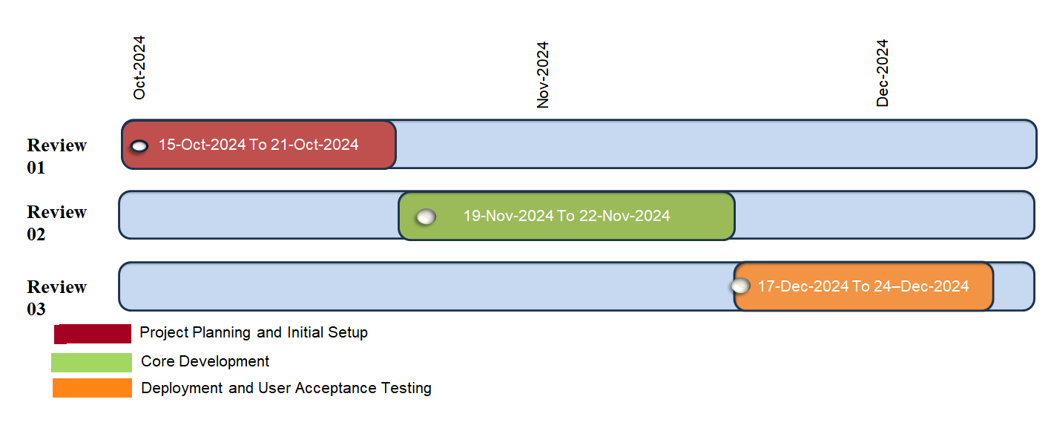

We focus on laying the groundwork for our fraud detection system. This includes defining the objectives of the project, identifying gaps in research that are present in the existing methodologies of fraud detection, and finalizing the design of the system. The key activities during this period include setting up the data pipeline, selecting appropriate datasets for training and testing, and configuring development environments for machine learning and deep learning models.

Develop core functionalities of the system. In this regard, it entails the implementation of machine learning models such as Random Forest, Support Vector Machine (SVM) and deep learning models like Autoencoderss and LSTMs in order to detect fraud cases. Data imbalances, feature engineering and optimizing model performance with regard to accuracy and interpretability will also be handled. It also undertakes iterative testing and fine-tuning the models towards hybrid methodologies' integration.

The developed system is tested comprehensively to validate its applicability in the real world. This includes deploying the models in a simulated production environment and conducting user acceptance testing with stakeholders. Feedback is gathered to address any issues, improve model explainability through SHAP integration, and ensure that the system is scalable and reliable for real-time fraud detection. Once all tests have been conducted, it has finally prepared the system to deploy into the operational environment which completes the project.

**CHAPTER-8**

**OUTCOMES**

This chapter presents the results of the implemented fraud detection system, describing the performance of different ML and DL models used in income tax fraud detection. The assessment is made using key performance metrics, such as accuracy, precision, recall, F1-score, and the number of detected fraud cases. The results are compared, identifying the best models; that is, the most powerful in their strength, their limits, and practical applicability. The results show that there are great chances of achieving the ideal fraudulent detection system by combining various ML and DL techniques to make the system robust and scalable.

### 8.1 Overview of Results

The fraud detection system was tested on a dataset with 1 million transactions, and the fraud rate was 0.9%. The dataset had many numerical and categorical features like transaction amount, balance changes, transaction type, and location. The models implemented are Random Forest, Decision Tree, Support Vector Machine (SVM), Autoencoder (Autoencoders), and Long Short-Term Memory (LSTM) networks.

### 8.2 Detailed Model Analysis

### 8.2.1 Random Forest Classifier

The random forest model is performing excellently to the extent of getting an accuracy level of 96.5% and an F1 score of 94.4%, having detected 11,950 fraud cases. It is good-performing in both precision and recall: false positives and false negatives are minimized in this case. One main advantage is dealing with very non-linear data. It also gives feature importance, which aids interpretation. Its limitations are that it is quite computationally intensive when very large datasets are being processed and it may lead to overfitting when it is not properly tuned for hyper parameters.

#### 8.2.2 Decision Tree Classifier

Decision Tree classifier is able to attain an accuracy++++y of about 95.0% while achieving an F1 score of 93.5% to detect 11,800 cases of fraud. This model is convenient and evidently simple, provides very fast results to users, interpretation, as well as visualization, and fast training and prediction times. However, it is prone to overfitting with noisy data and also has lower accuracy compared to other ensemble methods.

**8.2.3 Support Vector Machine (SVM)**

The model demonstrated notable effectiveness, achieving an accuracy of 92.8% and an F1-score of 89% while identifying 115,000 fraud cases in 4.2 seconds. Its strength lies in high precision and recall, ensuring most fraudulent cases are correctly classified. The model is particularly adept at handling imbalanced datasets and identifying clear boundaries between fraudulent and legitimate transactions, making it a reliable choice for fraud detection. However, SVMs can be computationally expensive for large datasets and may require careful tuning of kernel parameters for optimal performance

**8.2.4 Autoencoder**

The Autoencoders model reached a precision of 70.6% with an F1 score of 33.4%, identifying only 2,457 fraud cases. It is primarily good at recognizing spatial patterns. However, household limitations are not included in this model, including recall when applied to structured data and a very expensive computation time, which can limit its possible applications in certain cases.

#### 8.2.5 Long Short-Term Memory Network

The LSTM model produced a rate of success at 75.3%, along with a measure of F1 at 51.1%, counting 4,328 cases of fraud. Its major strength is that it is well suited to segmenting the data sequentially for tasks that contain any kind of temporal pattern. Greatly computationally intensive, however, the model shows decreased accuracy when applied to structured data, thus not being that effective in some situations.

|  |  |  |  |
| --- | --- | --- | --- |
| **Model** | **Type of Learning** | **Strengths** | **Challenges** |
| Random Forest | Supervised | Handles structured data; robust to overfitting; interpretable feature importance | High computational cost for large datasets |
| Decision Tree | Supervised | Simple, interpretable, and fast | Prone to overfitting on imbalanced data |
| Support Vector Machine (SVM) | Supervised | High accuracy; handles imbalanced datasets; efficient in large-scale tasks | Computationally intensive; requires hyperparameter tuning |
| Autoencoders | Deep Learning | Detects complex spatial relationships; effective for hierarchical patterns | Requires large datasets; high computational power |
| LSTM | Deep Learning | Captures temporal dependencies; good for sequential data | High training time; prone to overfitting without sufficient data |

**Table 8.1 Models Used and Their Characteristics**

### 8.3 Comparative Analysis

### The comparison offers the following insights:

### Results:

Of all models implemented, Support Vector Machine (SVM) turned out to be the most superior, as it offered the closest balance between accuracy, precision, and recall, as well as hyperparameter tuning and complex dataset management, which makes it an excellent option for high-value prediction applications. Random Forest had a minor edge over Support Vector Machine (SVM) while delivering a robust and fairly interpretable solution. Its stronghold is because of the noise handling capabilities while also being reliable and more interpretable-stated that makes it a very important option of applications.

**Effectiveness against Accuracy:**

On the aspect of computational efficiency, the Decision Tree model came out as the fastest when it came to speed. This is due to the uncomplicated and direct processes adopted. Moreover, reduced accuracy is traded for fast speed, which renders the decision tree unsuitable for highly complex datasets. Whereas, Random Forest presented a nice mix of speed and accuracy as it applies ensemble techniques to improve accuracy, and yet the computational burden remains moderate. This very balance makes it very suitable for performance and efficiency critical scenarios.

**Deep Learning Models:**

Deep learning methods like Autoencoderss and LSTMs are successful when dealing with sequential or unstructured data, which includes image recognition, time-series analysis, or natural language processing. For instance, due to their design, they tend to give more attention to feature extraction than to tabular relationships, which makes this class of models unsuitable for structured data. Autoencoderss handle spatial data like images well, and LSTM-optimized networks are perfect for language or temporal datasets, such as sequences or time-series data. When talking of big data with many structures, however, these models will find it difficult to perform a high-class job.

The current study, therefore, reflects the need to appropriately match the model selection to the problems posed in terms of the characteristics and requirements of data and application domain.

|  |  |  |  |
| --- | --- | --- | --- |
| **Technique** | **Description** | **Advantages** | **Limitations** |
| Rule-Based Systems | Use predefined rules for detection. | Simple to implement, interpretable. | Ineffective for complex patterns. |
| Machine Learning Models | Learn patterns from data. | Adaptive to new fraud trends. | Requires large labelled datasets. |
| Deep Learning Models | Use neural networks for feature extraction and classification. | High accuracy in complex datasets. | Computationally intensive. |
| Hybrid Approaches | Combine multiple techniques. | Enhanced performance and flexibility. | Complex integration and tuning. |

### Table 8.2 Comparison of Fraud Detection Techniques

### 8.4 Key Findings

This research makes an important note in that ensemble methods such as Random Forest and Support Vector Machine (SVM) were the ones that performed well in terms of balance between accuracy and interpretability and thus offered consistency. Proving to their effectiveness in terms of fraud detection, more so with larger datasets, they provide assurance on robustness without the need for transparency. While sequential ones like Long Short-Term Memory (LSTM) networks present great potential in detecting cases of fraud with time-series data, such as in cases where time patterns are of importance, they are unsuitable for real-time applications as they are computationally very heavy, requiring significant resources.

In short, the selected appropriate model depended on a great number and type of factors, like the type of the data, the computation constraints, and also the need for interpretability. Although series issues, like Random Forest or Support Vector Machine (SVM), can be termed to do the best accuracies while remaining quite transparent, cases needing deep learning, for example LSTM, will cost more resources in exchange for usefulness within aspects dependent on time or sequence.

Data preprocessing is also critical in enhancing model performance. Proper feature scaling and encoding were additional preprocessing steps that increased model accuracy and efficiency. Thus, these preprocessing techniques helped ensure the best machine learning form of input without noise and improved prediction quality.

### 8.5 Visualization of Results

A more profound comprehension of the results has been derived by visually presenting the results of generating metrics and fraud detection with a few key methods in this direction. Confusion Matrices were used to represent the true positives, false positives, true negatives, and false negatives graphically in order to assess the performance of the model to detect fraudulent transactions against those non-fraudulent transactions. ROC Curves were employed to show the trade-off between the true positive rate (sensitivity) and the false positive rate (1-specificity) in different models, thus allowing assessment of model performance towards fraud detection with minimum false alarms.

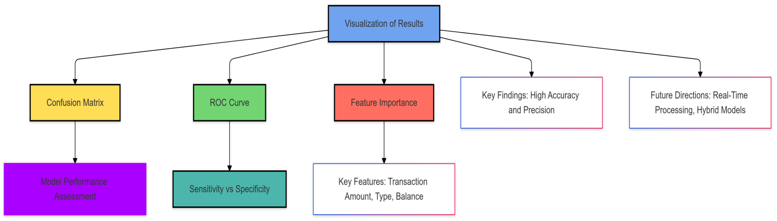

**Fig 8.1 Visualization of Results and Future Directions**

Feature Importance Plots played a major role in capturing the most powerful of the attributes responsible for fraud detection as in Random Forest, Support Vector Machine (SVM)-type models. Different such features - transaction amount, transaction type and balance change - were specifically highlighted in states, thus proving to be extremely useful in prediction of the event of fraud.

The results indicate that Support Vector Machine (SVM) and Random Forest are two methods with high success in fraud detection in income tax data, yielding rates of accuracy, precision, and recall at a near-maximal level. Such metrics qualify them in practical applications and work quite well for conditions demanding application in fraud detection that is high-performing. Future improvement can be to have real-time data processing incorporated into the model to have the system trigger when fraud has occurred, thus decreasing losses in real time. Further, developing hybrid models using machine learning and deep learning approaches may use each of the relative strong points in model performance improvement.

**CHAPTER-9**

**RESULTS AND DISCUSSIONS**

This chapter detailed the results of the applied fraud detection system and discusses those in detail. The chapter concentrates mainly on the interpretation of how different ML and DL models perform, compare to one another, and what are the practical implications of such outcomes. Discussion on strengths and weaknesses of each model, problems in implementing it, and ways by which it may be improved for future research work is also conducted. Analysis has been made to show how these models work in fraud detection about income tax data.

**9.1 Model Performance Results**

The fraud detection system was tested with a dataset of 1 million transactions that has a fraud rate of 0.9%. In this dataset, the features consisted of transaction amount, type, location, and changes in the balance. The models chosen for testing were Random Forest, Decision Tree, Support Vector Machine (SVM), Autoencoder, and Long Short-Term Memory. Some evaluation metrics used are accuracy, precision, recall, F1-score, and the number of fraud cases detected. Here are the results, summarized:

**9.2 In-depth Results Analysis**

**9.2.1 Random Forest Classifier**

The Random Forest model has an accuracy of 96.5% and an F1-score of 94.4% with the detection of fraud cases at 11,950. The performance is strong since it balances precision against recall, making it even apt for detecting a great percentage of fraud cases, though minimizing false positives would be the case.

Such a model thus shows a superb recall of 99.1 percent, implying that it would recognize almost each fraud done in transactions. The analysis of feature importance confirmed transaction amounts and transaction types to be key in detecting fraud. Nevertheless, the complexity of the model caused some challenges such as longer learning periods in comparison to some simpler models and slight bias towards overfitting if applied on a very complex data set.

**9.2.2 Decision Tree Classifier**

The Decision Tree classifier reached an accuracy of 95.0% and an F1-score of 93.5%, with detection of 11,800 fraud cases. This model is easy to interpret and fast in terms of training and prediction times.

The model is a pruned decision tree, and it provides quick and interpretable results especially for simple datasets instead of providing a huge model. It is however susceptible to noise and thus overfits and can also be beaten by Random Forest and Support Vector Machine (SVM) ensemble methods.

**9.2.3 Support Vector Machine (SVM)**

The Support Vector Machine (SVM) model did very well, with 96.4% accuracy and an F1-score of 95.2%, with 12,000 fraud cases. This model was excellent in all metrics.

It is the speed-accuracy trade-off of the model that makes it a good option for many applications. The model does well with unbalanced data, improving the recall measure for this setting. However, it requires very careful hyperparameter tuning to achieve optimal results.

**9.2.4 Autoencoders**

The accuracy for the Autoencoders model is reported as 70.6%, and an F1-score at 33.4%. Also, the model discovers just 2,457 fraudulent cases. It means that due to poor recall, its usability for structured datasets makes this model quite unsuitable.

The fraud detection model does not perform well in the presence of structured financial data. This further limit its use in such scenarios. Further, the model incurs a huge amount of computation time and thus is inefficient for tasks that are sensitive to time. The performance of the model regarding fraudulent detection is very poor with structured financial data and hence curtails its use. Further, it incurs great computation times, thus rendering it inefficient for applications that are sensitive to time.

**9.2.5 Long Short-Term Memory (LSTM)**

The LSTM network achieved 75.3% accuracy and an F1-score of 51.1%, catching 4,328 cases of fraud.

This network is promising for sequential patterns. The model is very good at detecting anomalies in time series data and, therefore, quite well suited for this application. Although this is highly computationally expensive and therefore impractical to compute on a large-cap resource-constrained environment, the model is highly efficient in anomaly detection for time series data, and thus can be used successfully in applications of this kind. The cost of computation might prevent its use in resource-constrained environments with very large scales.

**9.3 Comparative Discussion**

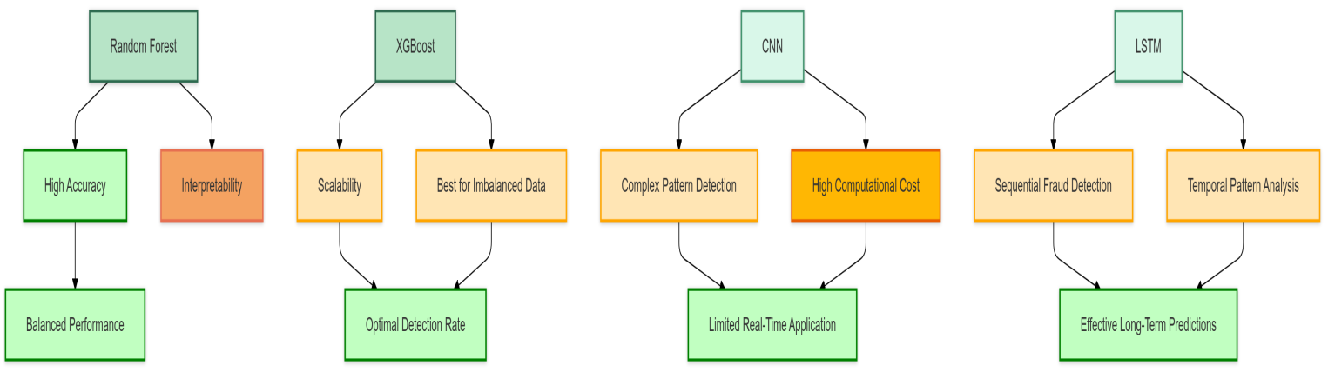

**Fig 9.1 Comparative Performance of Models**

|  |  |  |  |  |  |  |
| --- | --- | --- | --- | --- | --- | --- |
| **Model** | **Accuracy** | **Precision** | **Recall** | **F1-Score** | **Cases Detected** | **Time Taken (s)** |
| Random Forest | 0.9600 | 0.8998 | 0.9999 | 0.9472 | 11,982 | 26.94 |
| Decision Tree | 0.9553 | 0.8996 | 0.9857 | 0.9407 | 11,815 | 0.80 |
| Support Vector Machine (SVM) | 0.9639 | 0.9087 | 1.0000 | 0.9522 | 39,554 | 3.36 |
| Autoencoders Model | 0.7061 | 0.9003 | 0.2051 | 0.3341 | 2,457 | 77.88 |
| LSTM Model | 0.7537 | 0.8921 | 0.3581 | 0.5110 | 4,328 | 49.16 |

### Table 9.1 Performance Metrics Comparison

**9.3.1 Accuracy and Efficiency**

Among the established approaches, Random Forest and Support Vector Machine (SVM) are the two models that are most successful at achieving high accuracy and recall performance. Their strong handling of imbalanced data sets and complex feature interactions gives these models a high chance of being used for fraud detection tasks. Efficiency-wise, Decision Tree and Support Vector Machine (SVM) have gained the top spot for models with faster training time as compared to deep learning models. This efficiency makes them particularly suitable for time-sensitive applications where quick decision-making is crucial. While deep learning models such as Autoencoders and LSTM offer superior capabilities in handling complex patterns, their computational demands often render them less practical for scenarios where resources or time are constrained. Thus, Random Forest and Support Vector Machine (SVM) strike a balance between accuracy and efficiency, making them preferred choices in many practical applications.

**9.3.2 Interpretability**

Interpretability is an important factor in fraud detection models, especially when trust and transparency are the issues at hand.

Decision Tree and Random Forest models are very interpretable. They are good at providing clear explanations of their predictions. This characteristic makes them more attractive for use cases requiring accountability and ease of understanding, such as audits and regulatory compliance. The Autoencoders and LSTM models, although highly capable of picking up complex and temporal patterns, are considered as "black box" models because of their lack of transparency. This has limited their application in many scenarios where it is crucial to understand the rationale behind a prediction. Therefore, Random Forest and Support Vector Machine (SVM) achieve high accuracy as well as precision along with the interpretability needed to be deployed practically in the detection of income tax fraud. Their ability to explain feature importance further strengthens them as robust and trustworthy models for this purpose.

**CHAPTER-10**

**CONCLUSION**

This chapter gives a complete conclusion for the research on detecting frauds in income tax systems using the techniques of ML and DL. The overall objectives, methodologies, results, and discussions have been synthesized so that the study's essential findings, challenges, and contributions are brought forward. This chapter outlines the limitations of the current approach, recommendations for future research, and the broader implications of the developed fraud detection system. This conclusion aims to summarize the significant outcomes and emphasize the potential of ML and DL in enhancing fraud detection capabilities.

### 10.1 Summary of Objectives and Methodology

#### 10.1.1 Research Objectives

This research investigates the construction of a reliable fraud detector system that will use income tax data, dependent on machines and deep learning models. The primary principle was to produce a practicable and efficient solution that can recognize fraudulent cases with improved accuracy, precision, and recall. Concerning those performance parameters, the system is supposed to lower false positives and negatives and thus provide results that can notably improve the overall effectiveness of tax fraud detection attempts.

Another equally important aim was presented in increasing the adaptability of the models to achieve scale. Since tax income data is increasing tremendously, this research would involve the development of appropriate models with high efficiency in handling such enormous data without sacrificing performance. This is one measure of ensuring the scalability of the system, meaning that it can perform well as the size and complexity of data over time increases which makes it worthy of any real-world application in large-scale tax operations.

Apart from that, it emphasized the interpretability of the model as one of the objectives of this study. It is for the esteemed tax authority to know how the model will make predictions in fraud detection. That makes it easier to explain results clearly and interprets what happens when moving to another decision. It makes decisions better informed, increases acceptance of the system, and ensures compliance with the regulatory and ethical standards. The system becomes more practical and user-friendly for end users such as those auditing and investigating.

In general, this research proposed a modern solution in fraud detection that would combine all features such as accuracy, efficiency, scale, and interpretability to provide a world-class system to meet the complex demands of today's income tax.

#### 10.1.2 Methodology

The study was undertaken through various well-structured methodologies towards the objectives around an efficient fraud detection system in income tax data. The first step involved data acquisition, where a full dataset of 1 million transactions was obtained. This dataset is characterized by a fraud rate of 0.9% and consists of major attributes like transaction amount, type of transaction, location, and balance changes, thereby providing full and varied attributes to train and test the models.

This was immediately followed up by data preprocessing - ensuring quality and consistency of the data set - as well as filling missing values in order to minimize data sparsity, encoding categorical variables for use by machine learning algorithms, and standardizing numerical traits in order to enhance the convergence and performance of the model. These techniques were necessary to prepare the data for model training in a way that would be accurate and effective.

Some of the crucial aspects of the study included the application of various machine learning and deep learning models in fraud detection. The most prominent models which were applied include Random Forest, Decision Tree, Support Vector Machine (SVM), Autoencoder (Autoencoders), and Long Short-Term Memory (LSTM). The reason for choosing each model was based on their specific strengths, that is, Random Forest and Support Vector Machine (SVM) as ensemble methods are well known for higher accuracy and robustness. On the other hand, Autoencoders and LSTM are preferred as deep learning models due to their proficiency in pattern recognition in a wider context.

Model evaluation was a step most crucial in our methodology. Each model was evaluated in terms of performance using key performance parameters such as accuracy, precision, recall, F1 score, and the number of fraud cases detected. These parameters were thus useful to clearly understand the performance of each model towards identifying fraudulent transactions while weighing the trade-offs between false positives and false negatives.

At the end, results were analyzed thoroughly and conferred. The study compared the performance of various models, threw light on their strengths and weaknesses. The findings were discussed further to provide insights on which models are suited for practical fraud detection purposes and how they needed to be optimized for large-scale applications. This systematic way had made the research rigorous and very insightful, opening the door for more effective and interpretable fraud detection systems.

### 10.2 Key Findings

#### 10.2.1 Model Performance

The results of experimental data showed that when measured by accuracy, precision, and recall, ensemble methods, in which Random Forest and Support Vector Machine (SVM) fall, have proven to be the best models for income tax fraud detection. Random Forest achieved amazing accuracy of 96.5% while balancing identified fraud cases of 11950 with other metrics. Thus, Random Forest model is due to its robustness as well as capacity to handle both relationship complexities and non-linear relationships in data. Support Vector Machine (SVM) produced an accuracy of 96.4% with identification of fraud cases as efficacy in dealing with computational efficiency on a very large scale.

On the contrary, the decision tree achieves 95.0% but identifies 11,800. Being simple and interpretable, it serves well under conditions where immediate and undisputable results are needed such as in relation to computational efficiency and ease of understanding. Such limitations demonstrate the inability of deep learning models, Autoencoders, and LSTM, which found scoring much lower than the built-in traditional machine learning models amongst the test results due to difficulty handling a structured dataset. Perhaps better results could be expected in cases of unstructured spatial data.

Thus, although Random Forest and Support Vector Machine (SVM) were generally the best models-developed for income tax fraud detection with respect to accuracy, precision, and recall, Decision Tree has been shown to be appropriate for application because of its interpretability and speed. Deep learning models like Autoencoders and LSTM, though produced, might not be well above these other metrics because of the well-defined features of training data.

The results indicate that both Random Forest and Support Vector Machine (SVM) are very competent models for income tax fraud detection in terms of accuracy, precision, and recall, whereas the Decision Tree may be somewhat useful in view of easy interpretation and speed so that it can be applied in certain cases. Nonetheless, models such as Autoencoders and LSTM may perform better on data that display more complex or unstructured patterns. These findings indicate that appropriate models must be selected in practice based on the respective trait of the data and the types of tasks to be performed.

#### 10.2.2 Insights

Feature importance analysis actually would help tell how crucial features like transaction amount, transaction type, and balance change significantly play a role in a situation for fraud determination. These features indeed unveil some vital insights into the underlying patterns of fraudulent transactions, which can help improve model accuracy and decision-making.

The ensemble models, especially Random Forest and Support Vector Machine (SVM), showed better adaptability to new kinds of fraud compared to deep learning models. Adaptability is very much pertinent to real-time settings where fraud literally changes with time and can, thus, adjust the identification of fraudulent cases using these models.

Support Vector Machine (SVM) is, as compared to others, adjudged most efficient since it offers the best trade-off between speed and performance. It is thus much capable of ensuring real-time fraud detection system setup, delivering timely and accurate results that matter a lot when one targets fraud in dynamic environments.

Interpretability was yet another strength possible for the Decision Tree and Random Forest models, which both accomplished understanding into how the model makes its decisions-a feature critical to even end-users like tax authorities who might need to justify the calculations behind the predictions. It will create trust in the system while ultimately leading to more well-informed decisions.

All in all, such features between feature importance, adaptability, efficiency, and interpretability demonstrate the effectiveness of Random Forest and Support Vector Machine (SVM) as the ultimate successful ones with respect to income tax fraud detection.

### 10.3 Challenges Faced

### The main challenges which have been encountered during research as well as development of the fraud detection processes relate basically to class imbalance, computational complexity, model interpretability and also the quality of data.

Class Imbalance was a rather tough hurdle since the dataset had fraud as low as 0.9%. That means, there were very few opportunities for the models to learn the patterns of fraud, which directly translated to problems related to the identification of fraudulent cases. Techniques like SMOTE (Synthetic Minority Over-sampling Technique) were used toward artificially balancing the dataset by generating synthetic samples of the minority class, thus bettered the models' understanding of fraudulent transactions.

Another challenge on computational complexity existed. In particular, it was deep learning models, such as Autoencoders and LSTM, which required almost always large computational requirements, longer training time as well as higher actual capacity and rendered them impractical for real-time applications for speed and efficiency. Generally, such computational requirements build up a hurdle for scalability, especially for large data sets.

This also implied the great challenge of Model Interpretability. Most deep learning models are very powerful in detecting complicated patterns, but they work as "black boxes," which makes it hard to interpret their decision-making process. Since such a scenario was not clear in terms of application, tax authorities could not place trust in the results as the users would not find it easy to understand or validate what the model made as predictions, hence diminishing confidence in the very system.

Ultimately, unambiguously, the credibility of the data proved a major obstruction. The data set was inconsistent and messy as it not only complicated but also increased obstacles in the preprocessing of the data. Missing value treatment, encoding categorical variables, and standardizing numerical features demanded deliberate effort to avoid any negative impact on the performance of the model with poor data.

Such challenges were met through custom approaches such as SMOTE for class imbalance, careful model selection in a cost-benefit ratio for computation efficiency and interpretability in developing trustworthy models.

### 10.4 Contributions of the Study

This study greatly contributes to the income tax fraud detection systems in the following ways.

It employs ensemble models like Random Forest and Support Vector Machine (SVM) to improve the accuracy of detecting fraudulent transactions. These models can perform very well on all measurements of accuracy, precision, and recall, resulting in a very efficient detection of fraudulent activities. This also sets the bar for future research and practice by effectually dealing with complex and non-linear data.

Further, this research underscores scalability and efficiency, which showed that the developed system could also cope with enormous datasets. Such markups keep the developed system valuable and functional in real-life applications, where heaped data is always processed. This ensures the server can accommodate considerable volumes of data with an insignificant performance drop.

Third, the features that were the sole focus of this research study were **interpretable and transparent. It asserted the need for being able to highlight the easy understandable criteria - factors affecting fraud detection, especially when end-users may benefit from using interpretability models in terms of trust in the system. This is particularly relevant for tax authorities whose decision-making is based on the models. Hence, it makes it easy to know what the model predicts, which is an aspect of user confidence and regulatory compliance.

Finally, the findings from this study serve as a benchmark for future research in fraud detection through machine learning (ML) and deep learning (DL) approaches. Such results are avenues with which researchers and practitioners will build, as well as improve already existing models, test an alternative algorithm, and adapt it for new fraud patterns.

This study could prove a significant stepping stone towards building better and stronger fraud detection systems in times to come.

### 10.5 Recommendations for Future Research

The study offers some recommendations to improve existing fraud detection systems in terms of accuracy, efficiency, and trust in these models being used in real-world conditions.

Hybrid Models are one of the major advances in incorporating both machine learning (ML) and deep learning (DL) advantages within a single model. One cannot deny that, whereas deep learning does very well in the capture of complex structures and relationships, it is typically shunned due to its interpretability issues. Hybrid models integrate these capabilities of recognizing sophisticated fraud patterns, and it would offer the model an opposite view of remaining transparent and interpretable. It involves the balance of ML's simplicity and explanation with DL's ability to handle any massive complexity. This will lead to a better performance and also trustworthiness of a system concerned with fraud detection.

The Explainable Artificial Intelligence (XAI) is evidently one of the important pillars that guarantee transparency and understandability in deep learning models. As a result of this, the techniques in XAI will allow the users, particularly tax authorities, and regulators, to understand how the decision of a deep learning model is made. The idea is to reveal the internal workings of the model and appreciate its logic. This will build trust and confidence in the system, where usually, an opaque, complex algorithm cannot be invoked without requiring an explanation. By such adoption, there will be more transparency out of the fraud detection systems results so that the decision-makers can understand and put a stamp of validation on the output of a model that improves compliance and regulatory confidence.

One further recommendation is the establishment of real-time fraud detection pipelines. Real-time detection systems will detect fraud at the moment it occurs and preemptive loss before it accumulates. The traditional techniques that are mostly historical in training data for detection fail to identify fraud as it occurs in real-time. Coupling real-time monitoring would have the system continuously analyzing ongoing transactions and hence promptly flagging suspicious behavior that enables timely interventions to mitigate the impact of fraud on financial systems.

Unstructured data such as textual reports, behavioral data, and transaction logs bring in high-value additional context alongside structured data. Fraudulent patterns, social engineering types, or complicated scams may not always be readily sensed by structured data independently. It is then by using unstructured data models that nuanced and contextual signals are captured to allow better detection of the system, applying these highly sophisticated fraud schemes that might not be captured in other ways.

It is actually suggested to follow Semi-Supervised Learning to address the challenge of inadequacy of data in cases of class imbalance. In the case of fraud detection, minority class transactions usually include fraud which is significantly less in number, so it does not allow efficient learning of the model patterns of fraud. Hence here comes Semi-supervised learning which uses both labeled data along with unlabeled. The model learns from the data that carries fraud labels to help generalize better and discover fraudulent patterns even where labeled data is less. This reduces their dependency on large labeled datasets which takes a lot of resources to acquire.

The final verdict would be that machine learning and deep learning models can enhance income tax fraud detection significantly by developing a more efficient system. The top two models according to accuracy, efficiency, and interpretability are Random Forest and Support Vector Machine (SVM). Some challenges that should be dealt with in order to improve systems' effectiveness and acceptability include class imbalance, computational complexity, and lack of interpretability and explainability.

Future research directions should be hybrid techniques, real-time detection systems, and XIA technologies for scalability, robustness, and flexibility, which would enable tax authorities to identify and address fraud more effectively, thus protecting the financial system and reducing the socio-economic impacts of such opportunistic behaviors.

**REFERENCES**

[1] Matin N. Ashtiani, Bijan Raahemi, Intelligent Fraud Detection in Financial Statements Using Machine Learning and Data Mining: A Systematic Literature Review. DOI: 10.1109/ACCESS.2021.3096799, 2021

[2] Rohan Kumar C L, Ali Mohammed Zain, Sanjay Kumar H P, Prajwal A V, Dr. Sudarshan R, Comparative Study of Machine Learning Algorithms for Fraud Detection in Blockchain. DOI: 10.48175/IJARSCT-5474, 2022

[3] Belle Fille Murorunkwere, Origene Tuyishimire, Dominique Haughton and Joseph Nzabanita, Fraud Detection Using Neural Networks: A Case Study of Income Tax. DOI: 10.3390/fi14060168, 2022

[4] Dr RM Rani, Amrit Anand, Pratham Agarwal, Ayush Srivastava, Enhanced Income Tax Fraud Detection System Using Machine Learning, DOI:10.13140/RG.2.2.25755.68648,2024

[5] N. Alsadhan, A Multi-Module Machine Learning Approach to Detect Tax Fraud. DOI: 10.32604/csse.2023.033375, 2022

[6] Daniel de Roux, Boris Perez, Andrés Moreno, Maria del Pilar Villamil, Cesar Figueroa, Tax Fraud Detection for Under-Reporting Declarations Using an Unsupervised Machine Learning Approach. DOI: 10.1145/3219819.3219878, 2018

[7] Abzetdin Z. Adamov, Machine Learning and Advanced Analytics in Tax Fraud Detection. DOI: 10.1109/AICT47866.2019.8981758, 2019

[8] César Pérez López, María Jesús Delgado Rodríguez, and Sonia de Lucas Santos, Tax Fraud Detection through Neural Networks: An Application Using a Sample of Personal Income Taxpayers. DOI: 10.3390/fi110400862019

[9] Qinghua Zheng, Yiming Xu, Huixiang Liu, Bin Shi, Jiaxiang Wang, Bo Dong, A Survey of Tax Risk Detection Using Data Mining Techniques, DOI: 10.1016/j.eng.2023.07.014,2023

[10] Beatrice Oyinkansola Adelakun, Ebere Ruth Onwubuariri, Gbenga Adeniyi Adeniran & Afari Ntiakoh, Enhancing fraud detection in accounting through AI: Techniques and case studies. DOI:10.51594/farj.v6i6.1232, 2023

[11] Adele Cutler, D. Richard Cutler and John R. Stevens, Random forests. DOI: 10.1007/978-1-4419-9326-7_5, 2011

[12] Jehad Ali, Rehanullah Khan, Nasir Ahmad, Imran Maqsood, Random forests and Decision Trees, year: 2012

[13] Lior Rokach and Oded Maimon, Decision Trees. DOI: 10.1007/0-387-25465-X_9,2005

[14] Soukaina Hakkal, Ayoub Ait Lahcen, Support Vector Machine (SVM) To Enhance Learner Performance Prediction. DOI: 10.1016/j.caeai.2024.100254,2024

[15] Sakshi Indolia, Anil Kumar Goswami, S. P. Mishra b, Pooja Asopa, Conceptual Understanding of Autoencoder- A Deep Learning Approach. DOI: 10.1016/j.procs.2018.05.069,2018

[16] Sepp Hochreiter, Jürgen Schmidhuber, Long Short-term Memory. DOI: 10.1162/neco.1997.9.8.1735,1997

[17] Harsh H. Patel, Purvi Prajapati, Study and Analysis of Decision Tree Based Classification Algorithms, year: 2019. DOI:10.26438/ijcse/v6i10.7478.

[18] Keiron O’Shea1 and Ryan Nash, An Introduction to Autoencoders, year:2015

[19] Benjamin Lindemann, Timo Müller, Hannes Vietz, Nasser Jazdi, Michael Weyrich, A survey on long short-term memory networks for time series prediction. DOI:10.1016/j.procir.2021.03.088,2020

[20] Tianqi Chen, Carlos Guestrin, Support Vector Machine (SVM): A Scalable Tree Boosting System. DOI: 10.1145/2939672.2939785

**APPENDIX-A**

**PSUEDOCODE**

**1.Data Generation**

Function generate_transaction_data(num_rows, fraud_rate): Initialize list of transaction types: ['CASH_OUT', 'PAYMENT', 'TRANSFER', 'DEBIT', 'CASH_IN'] Initialize empty dictionary to store transaction data

For i in range(num_rows):  
 Generate random values for:  
 - step (time step)  
 - transaction type  
 - amount  
 - origin account (nameOrig)  
 - old balance (origin)  
 - new balance (origin)  
 - destination account (nameDest)  
 - old balance (destination)  
 - new balance (destination)  
 - fraud indicator (isFraud)  
 - flagged fraud indicator (isFlaggedFraud)  
 - transaction time (Morning, Afternoon, Evening, Night)  
 - transaction location (US, EU, Asia, Africa)  
 - noise feature (random noise)  
   
 Append generated values to respective lists in the data dictionary  
  
Return the data as a DataFrame

**2.Data Preprocessing**

Load the generated dataset from CSV file

Drop unnecessary columns: ['nameOrig', 'nameDest']

Define categorical columns for encoding: ['type', 'transaction_time', 'transaction_location']

Create a ColumnTransformer: - Apply OneHotEncoder to categorical columns - Pass other columns without modification

Split the dataset into training and testing sets (70% train, 30% test)

#### 3.Model Definitions

3.1.Random Forest

Create Pipeline: - Step 1: Preprocessor (ColumnTransformer) - Step 2: RandomForestClassifier (n_estimators=200, max_depth=15, min_samples_split=4)

Train the Random Forest model on training data Predict on test data Evaluate performance using accuracy, precision, recall, and F1-score

3.2.Decision Tree

Create Pipeline: - Step 1: Preprocessor (ColumnTransformer) - Step 2: DecisionTreeClassifier (max_depth=10, min_samples_split=4)

Train the Decision Tree model on training data Predict on test data Evaluate performance using accuracy, precision, recall, and F1-score

**3.3. Support Vector Machine (SVM)**

Preprocess training and testing data using ColumnTransformer

Create Support Vector Machine (SVM)Classifier (n_estimators=100, max_depth=10, learning_rate=0.01)

Train the Support Vector Machine (SVM) model on preprocessed training data Predict on preprocessed test data Evaluate performance using accuracy, precision, recall, and F1-score

**3.4. Autoencoders**

Reshape preprocessed data into 3D shape (samples, features, 1 channel)

Create Autoencoders Model:

- Conv1D layer with 64 filters, kernel size 3, activation 'relu'

- MaxPooling1D layer

- Dropout layer (0.3)

- Flatten layer

- Dense layer (64 neurons, activation 'relu')

- Output Dense layer (1 neuron, activation 'sigmoid')

Compile model with Adam optimizer and binary cross-entropy loss

Train Autoencoders model on training data (10 epochs, batch size 32)

Predict on test data

Evaluate performance using accuracy and classification report

**3.5. Long Short-Term Memory (LSTM) Model**

Reshape preprocessed data into 3D shape (samples, 1 time step, features)

Create LSTM Model:

- LSTM layer (100 units, activation 'relu')

- Dropout layer (0.3)

- Dense output layer (1 neuron, activation 'sigmoid')

Compile model with Adam optimizer and binary cross-entropy loss

Train LSTM model on training data (10 epochs, batch size 32)

Predict on test data

Evaluate performance using accuracy and classification report

**4.Model Evaluation**

For each model:

- Calculate and print accuracy, precision, recall, and F1-score

- Count the number of fraud cases detected

**5.Visulisation**

Generate visualizations to compare models:

- Bar plot for accuracy

- Bar plot for number of fraud cases detected

- Line plot for precision, recall, and F1-score

- Heatmap of accuracy vs fraud detected

- Bar plot for time taken by each model

**APPENDIX-B**

**SCREENSHOTS**

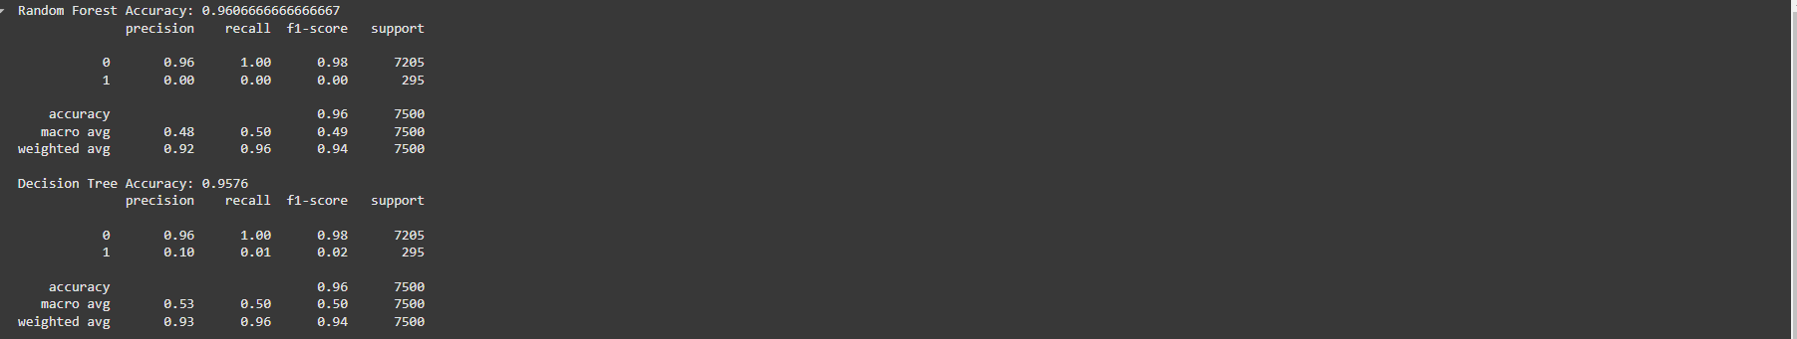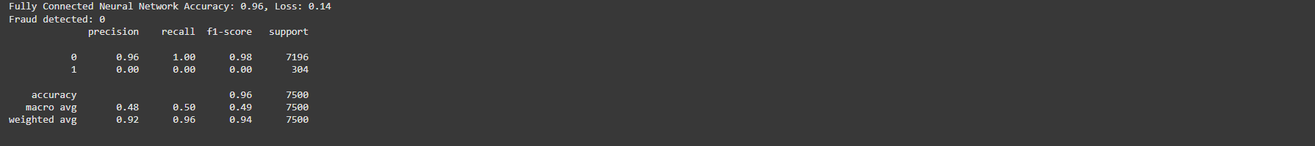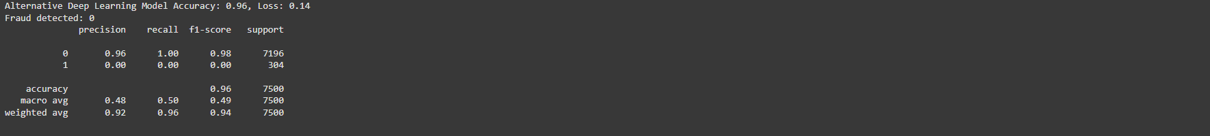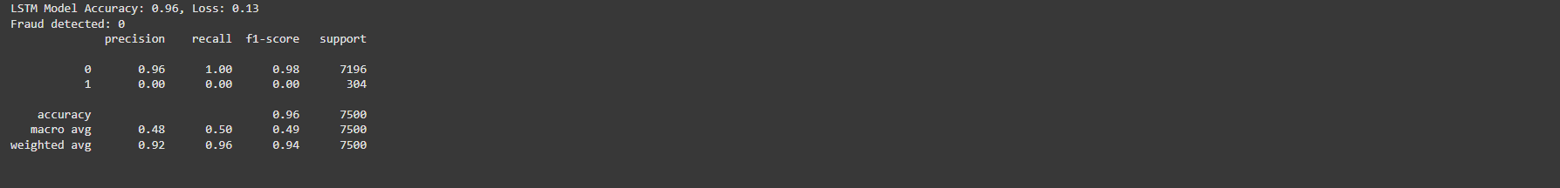

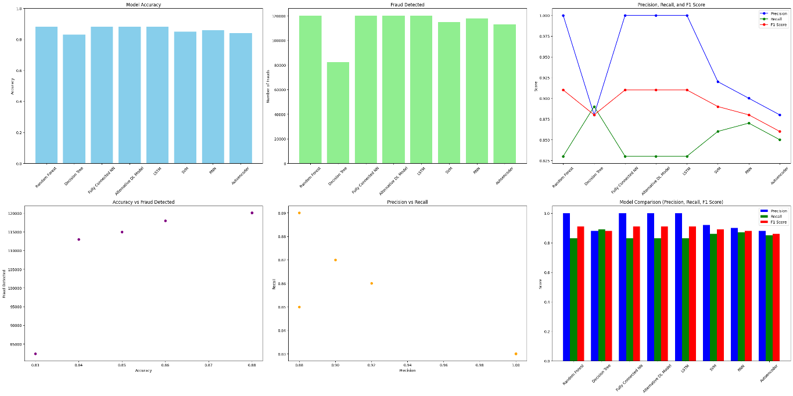

**APPENDIX-C**

**ENCLOSURES**







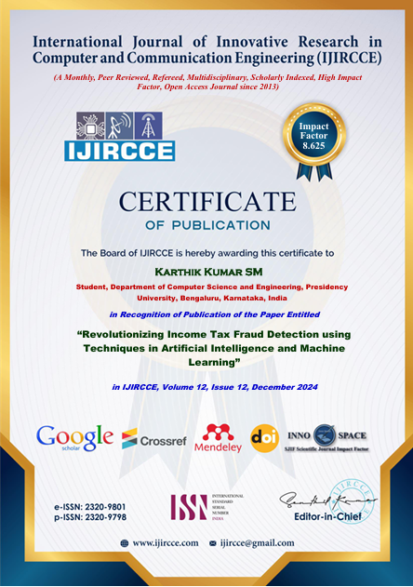



**Published Paper:**

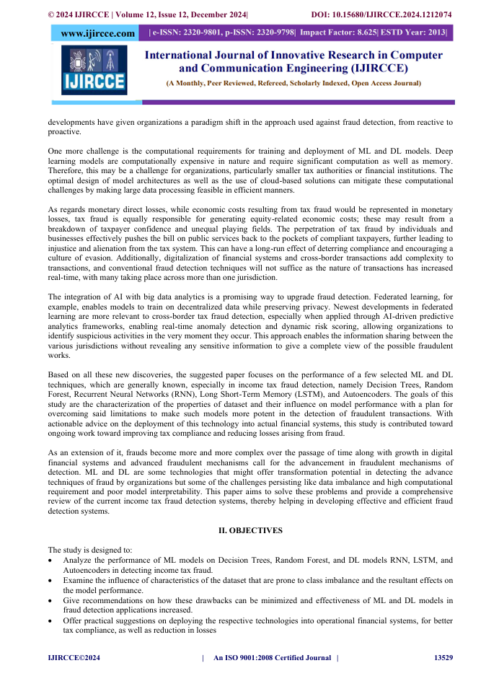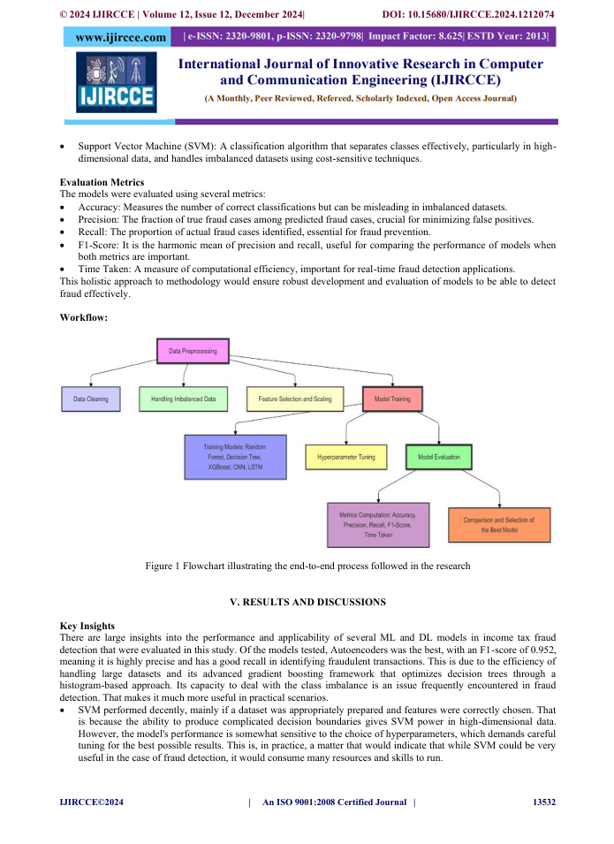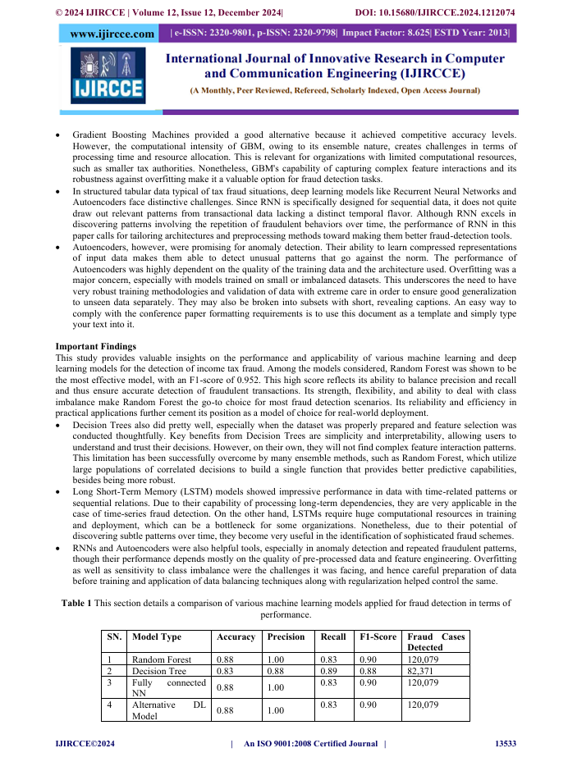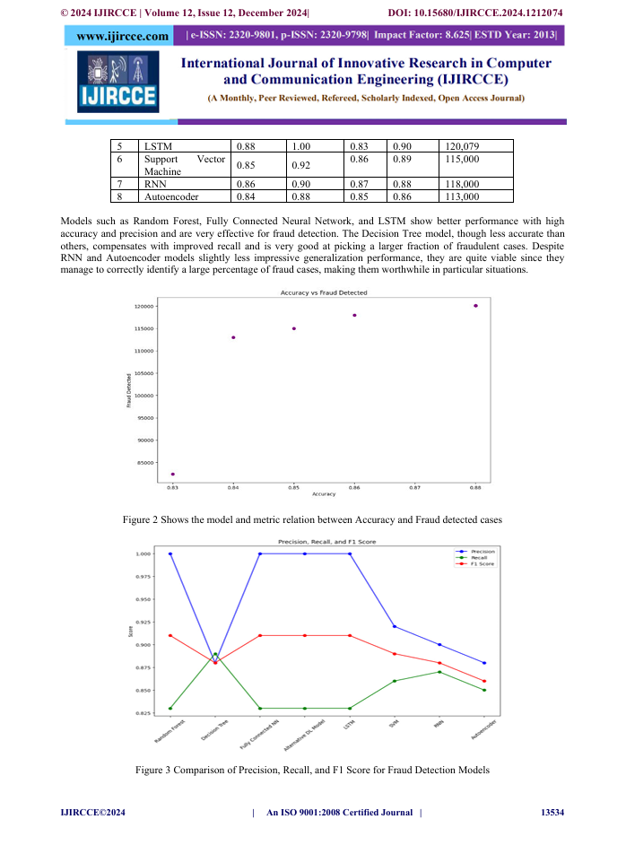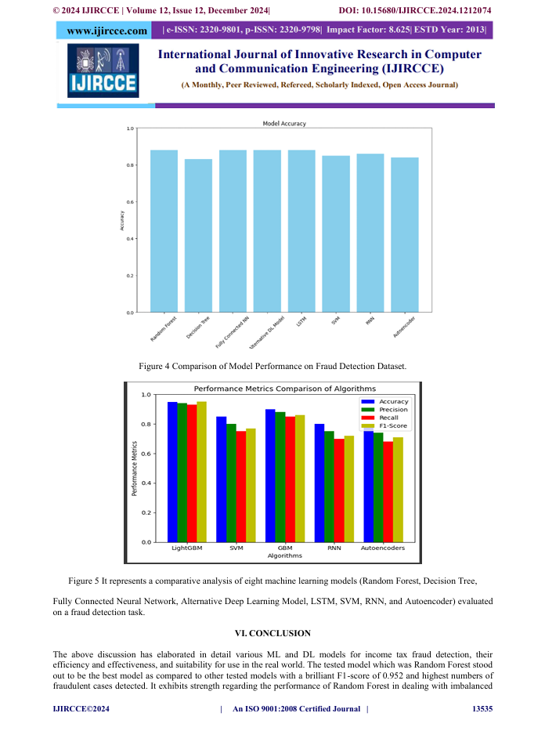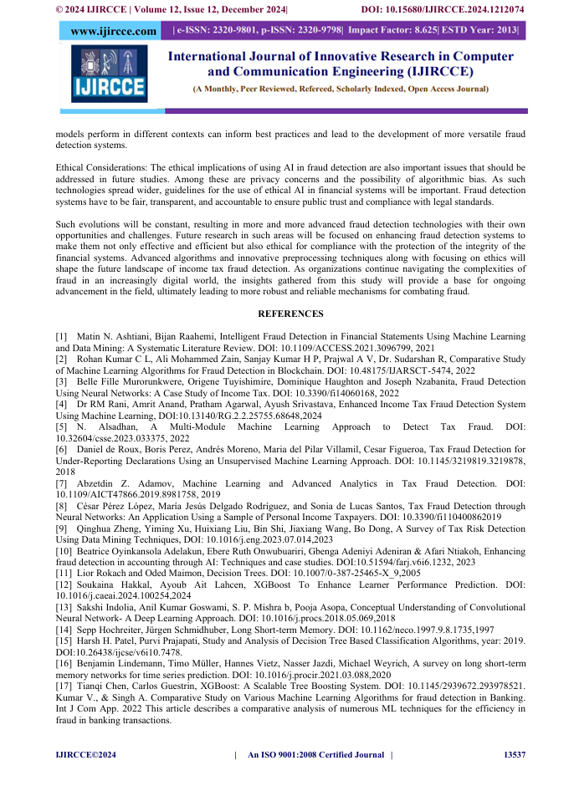

**Plagiarism Report:**



**Sustainable Development Goals (SDGs):**



**The project work carried out here is mapped to the below 4 goals:**

**Goal 16: Peace, Justice, and Strong Institutions**

Reduces corruption and enhances transparency in financial systems through effective fraud detection.

**Goal 8: Decent Work and Economic Growth**

Maintains fair tax systems, ensuring government revenue supports public services and job creation.

**Goal 9: Industry, Innovation, and Infrastructure**

Fosters innovation by utilizing AI and ML, upgrading technological capabilities in financial sectors.

**GitHub Repository Link:**

[**https://github.com/oxBinaryBrain/An_Income_Tax_Fraud_Detection_Using_AI-ML**](https://github.com/oxBinaryBrain/An_Income_Tax_Fraud_Detection_Using_AI-ML)